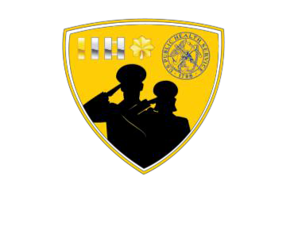JOAG Awards Committee

Mission: Facilitate the awards process and recognize junior officers for their accomplishments and commitment to the mission of the United States Public Health Service (USPHS).

# Committee Co-Chairs:

* LCDR Fengyee Zhou (fengyee.w.zhou@uscg.mil)
* LT Rachel McBride (rachel.mcbride@hhs.gov)

# SUBCOMMITTEES

## JOAG Awards:

Reviews and updates the nomination forms, selection criteria, and companion documents for all JOAG awards prior to the beginning of the awards process.

## VADM Richard H. Carmona Award:

Oversees and administers the process for receiving and processing nominations for the VADM Richard H. Carmona Inspiration Award.

## VADM C. Everett Koop Award:

Oversees and administers the process for receiving and processing nominations for the VADM C. Everett Koop Junior Officer Award.

## Junior Officer of the Year Award:

Oversees and administers the process for receiving and processing nominations for the Junior Officer of the Year Award.

## Excellence Award:

Oversees and administers the process for receiving and processing nominations for the Excellence Award.

## Standard Operating Procedures (SOP):

Reviews the Awards Committee SOP annually. Updates the SOP, as needed, and incorporates any changes.

## JOAG Recognition:

Oversees the recognition efforts for active JOAG participants, advisors, and other people JOAG chooses to recognize. Assists the JOAG Chair with the JOAG recognition certificates given during the annual USPHS Scientific and Training Symposium. Distributes the template for letters of appreciation to all JOAG Committee Chairs and Subcommittee Leads towards the end of the operational year. Coordinates plaques and gavels.

## Special Assignment Award (SAA):

Oversees the process of maintaining JOAG voting members’ activity logs related to their JOAG activities. Requests and reviews voting members’ eligibility (activity logs) for a SAA. Prepares the recommendation package for the SAA to be submitted to the Office of the Surgeon General towards the end of the operational year.

## The Committee also includes:

* Co-Secretaries (two)
* Website Coordinator

**Please visit our JOAG Awards Committee Website for more information:** (<https://dcp.psc.gov/osg/JOAG/committees_awards.aspx>)