JOAG Executive Committee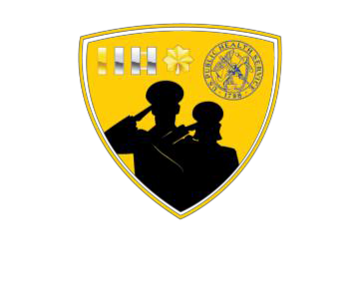

Mission: To serve the JOAG general membership in the execution of the JOAG vision, mission, and objectives.

# Committee Roster:

* Chair: LCDR Stephanie Mros ([Stephanie.Mros@ice.dhs.gov](mailto:Stephanie.Mros@ice.dhs.gov))
* Vice-Chair: LCDR Shamika Brooks ([Shamika.Brooks@fda.hhs.gov](mailto:Shamika.Brooks@fda.hhs.gov))
* Chair-Elect: LCDR Mouhamed “Mo” Halwani ([mouhamed.halwani@fda.hhs.gov](mailto:mouhamed.halwani@fda.hhs.gov))
* Co-Secretary: LCDR Michael Wandersee ([michael_wandersee@fws.gov](mailto:michael_wandersee@fws.gov))
* Co-Secretary: LT Xia Michele Lin ([wft4@cdc.gov](mailto:wft4@cdc.gov))
* Operations Liaison: LCDR Jackeline Rodriguez ([jackeline.rodriguez@cms.hhs.gov](mailto:jackeline.rodriguez@cms.hhs.gov))

# EXECUTIVE COMMITTEE (EC) ROLES

## Chair:

The Chair facilitates, organizes and maintains order in meetings of the group and meetings of the Executive Committee. The Chair also acts as a liaison between JOAG and the following entities: the Office of the Surgeon General, the Chief Professional Officer Professional Advisory Committee, Chief Professional Officers and Agency representatives.

## Vice Chair (COA/COF Liaison):

The Vice-Chair acts as Chair in the absence of the Chair, serves as the official JOAG liaison to the Commissioned Officers Foundation (COF) Board of Directors, and acts as the official Executive Officer Liaison to professional advisory committees and other groups as assigned by the Chair.

## Chair-Elect:

The Chair-Elect acts as Chair in the absence of the Chair and Vice-Chair. The Chair-Elect is the first year of a two-year term, serving as the JOAG Chair-Elect as well as the Chair of the Policy and Procedures Committee during year 1, and then becoming the JOAG Chair during year 2.

## Executive Secretaries:

The Executive Secretaries act as Chair in the absence of the Chair, Vice-Chair, and Chair-Elect. The Executive Secretaries inform the membership (via e-mail) of meeting times and conference line information, establishes agendas in collaboration with the Chair, distributes the agenda to members, prepares and distributes meeting minutes, serves as the Max.gov liaison, and maintains reports, attendance and official documents.

## Operations Liaison:

The Operations Liaison keeps the voting and general membership informed about JOAG financial and operational matters, maintains a record of JOAG funds held by the Commissioned Officer Foundation (COF) and ensures proper use and reimbursement of JOAG funds. The Operations Liaison is the point of contact for JOAG website social media platforms and virtual trainings

## EC Liaisons:

## EC members serve as EC Liaisons to JOAG Committees. Liaisons serve in an advisory capacity, review committee meeting minutes, provide guidance as needed, and assist committees in reviewing and finalizing new projects/proposals.

**Please visit our JOAG Executive Committee Website for more information:** (<https://dcp.psc.gov/osg/JOAG/committees_executive.aspx>)