

UNITED STATES PUBLIC HEALTH SERVICE COMMISSIONED CORPS

JUNIOR OFFICER ADVISORY GROUP

2021-2023 Voting Membership Biography

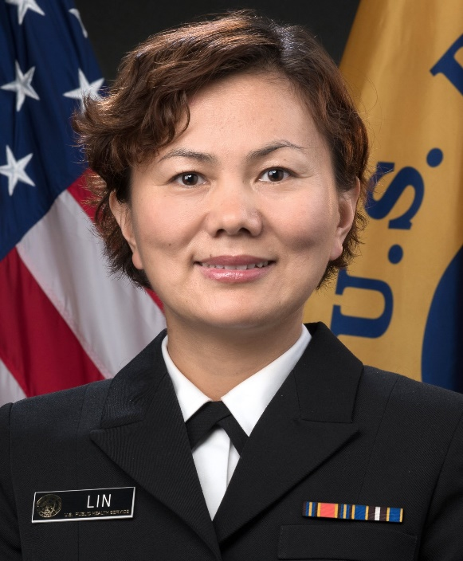

**Name:** LT Xia Michelle Lin

**Primary JOAG Role:** Executive Community Co-Secretary

**Secondary JOAG Role:** Scientist Category Liaison

**E-mail:** [xmlin@cdc.gov](mailto:xmlin@cdc.gov)

**Category**: Scientist

# PHS Call to Active Duty: 2019

**Current Position (Agency; Location; Position Title):**

* Centers for Disease Control and Prevention; Atlanta, GA; Epidemiologist

# Collateral Duties (Deployment Team, PAC, COA, Agency- or Public Health- Related, etc.):

* SciPAC Visibility, Science, and Category Day Subcommittees
* APAOC voting member alternate
* CDC/ATSDR PHS Award Board, division representative

# Favorite Quote:

**“***A leader is best when people barely know he exists, when his work is done, his aim fulfilled, they will say: we did it ourselves.****”* – Lao Tzu**