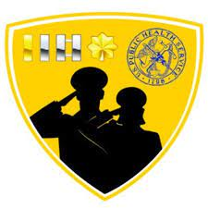 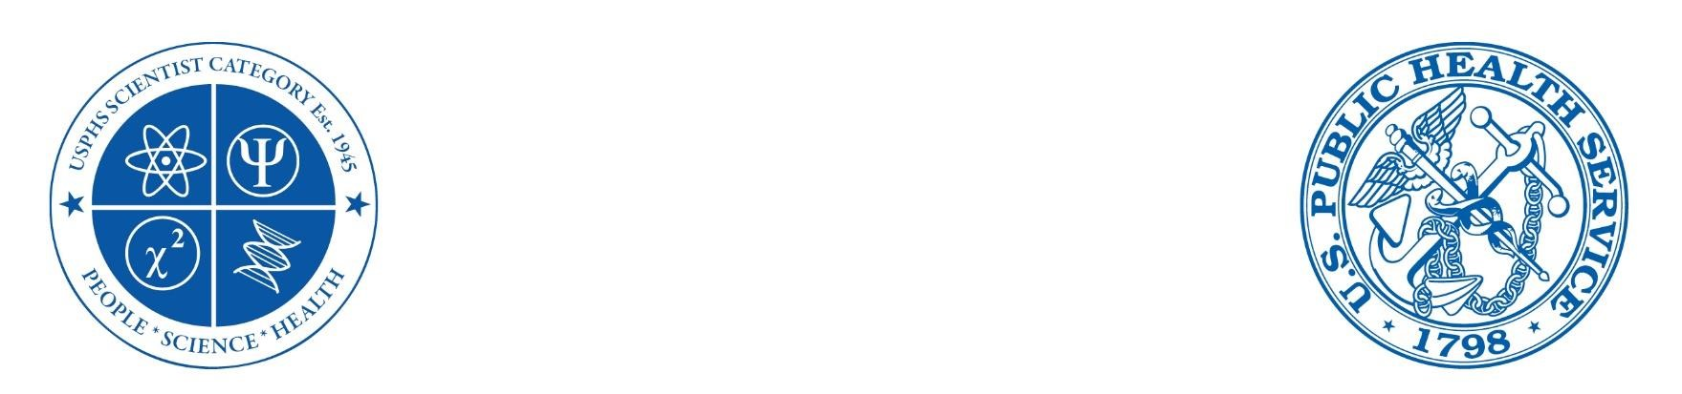

**Commissioned Corps of the US Public Health Service**

**JOAG Professional & Development Committee**

***Training and Education Subcommittee***

General Training Resources Guide for Junior Officers

Contributor: LT William Phan

February 2023

# Table of Contents

Table of Contents

Table of Contents 2

Purpose 3

Training categories 3

Emergency Preparedness 4

Applied Public Health 5

Leadership/Mentoring 7

Others 8

# Purpose

As a junior officer, it is essential to equip yourself with the knowledge and skills needed to perform your duties effectively, both as a professional in your respective category and as an officer. This guide provides you with various resources of general interest to support your training and professional development throughout your early career.

This guide is not designed to include all available training opportunities; therefore, please engage regularly with your agency and Professional Advisory Committee to individualize and update your training plan. The Training and Education Subcommittee will update this guide annually with feedback from junior officers.

# Training categories

## Emergency Preparedness

[Field Medical Readiness Badge (FMRB) Required Training Modules through CCHQ](https://dcp.psc.gov/ccmis/RedDOG/REDDOG_fmrb_Modules_m.aspx)

**Description**: An optional badge officers may choose to pursue, enhancing their knowledge and deployment-related skill-set. For any officer wishing to work towards their FMRB and qualify at the basic Readiness level, they must successfully complete the required online training sessions.

[Emergency Preparedness and Response Course through Joint Knowledge Online](https://www.health.mil/Military-Health-Topics/Education-and-Training/DMRTI/Course-Information/Emergency-Preparedness-and-Response-Course)

**Description**: Consists of four levels (Basic, Operator/Responder, Clinician, and Executive/Commander) targeted to a student's profession/job description. No cost. CEs for selected professions.

[DisasterReady](https://ready.csod.com/)

**Description:** Certifications in Humanitarian Aid and Development: Achieving certification demonstrates professional skills, knowledge, and commitment to your work while increasing your credibility and confidence. Employers in the sector are increasingly using certifications in their professional development and recruitment. Select from assessment-based certificates and certifications that are free or have an exam fee.

[FEMA Emergency Management Institute](https://training.fema.gov/is/)

**Description:** The Emergency Management Institute (EMI) offers self-paced courses designed for people who have emergency management responsibilities and the general public. All are offered free-of-charge to those who qualify for enrollment.

## Applied Public Health

[The Certificate in Public Health Practice through University of South Carolina](https://mysph.sc.edu/lms/course/index.php?categoryid=2)

**Description**: An 18 hour online professional development series consisting of six courses about general public health practice. No cost. Email certificate of completion for all six courses to receive the final certificate.

[Certificate in Public Health Management through Maine Public Health Training Center](https://mainepublichealth.org/public-health-trainings/certificate-opportunities/ph-management-course/)

**Description**: Build the knowledge, skills and confidence to work in public health management. No cost. Email certificate of completion for all courses to receive the final certificate.

[Upstream Certificate through Maine Public Health Training Center](https://mainepublichealth.org/public-health-trainings/certificate-opportunities/upstream-certificate-course/)

**Description**: Build the knowledge, skills and confidence to work collaboratively “upstream” to address health disparities, advance health equity, and improve health outcomes for patient populations, health care systems, and communities. No cost. Email certificate of completion for all courses to receive the final certificate.

[Foundations for Local Public Health Practice through Boston University School of Public Health](https://sites.bu.edu/masslocalinstitute/2021/06/29/foundations-for-local-public-health-practice-3/)

**Description**: Gives new and experienced local public health practitioners the core knowledge and skills necessary to increase the impact and efficiency of their work. No cost. About 35 hours to receive a certificate of completion. CEs for REHS and Massachusetts CHO, RS, and RN.

[Certificate in Global Health Practice through Unite For Sight, Inc.](http://www.uniteforsight.org/global-health-university/global-health-practice-certificate)

**Description:** Prepares students and professionals who will be involved in healthcare delivery in a resource-poor location. Submit 1-paragraph responses about each module of the online courses and receive an evaluation of Honors, Pass, Low Pass, or Fail on the final transcript. Total cost is $100.

[Graduate Certificate in Global Health and Global Health Engagement through Uniformed Services University of the Health Sciences (USUHS)](https://medschool.usuhs.edu/pmb/education/global-health-distance-learning-program)

**Description**: 15 semester credit graduate program that offers coursework in global health science and policy with an extra emphasis on real-world applications relevant to the U.S. military, the U.S. federal government, and our allies and partners. No cost.

[Ethical and Regulatory Aspects of Clinical Research through NIH Department of Bioethics](https://bioethics.nih.gov/courses/ethical-regulatory-aspects.shtml)

**Description**: Offered to anyone interested or involved in the ethics of clinical research with human subjects. Participants represent multiple disciplines including research teams, IRB members, physicians, psychologists, nurses, social workers, administrative staff, students, and others. No cost. must complete at least 3 Session Quizzes to receive a basic certificate of completion.

[Introduction to the Principles and Practice of Clinical Research (IPPCR) through NIH Office of Clinical Research](https://ocr.od.nih.gov/courses/ippcr.html)

**Description:** Trains registrants on how to effectively and safely conduct clinical research. The course focuses on the spectrum of clinical research and the research process by highlighting biostatistical and epidemiologic methods, study design, protocol preparation, patient monitoring, quality assurance, ethical and legal issues, and much more. No cost. Must achieve a score of 75% or higher on the final exam to receive a certificate of completion.

[Good Clinical Practice eCourse through Society of Behavioral Medicine](https://www.sbm.org/training/good-clinical-practice-for-social-and-behavioral-research-elearning-course)

**Description**: Free National Institutes of Health (NIH) training and certification for good clinical practice in social and behavioral research. No cost.

[Good Clinical Practice through National Drug Abuse Treatment Clinical Trials Network](https://gcp.nidatraining.org/)

**Description**: Designed to prepare research staff in the conduct of clinical trials with human participants. The 12 modules included in the course are based on ICH GCP Principles and the Code of Federal Regulations (CFR) for clinical research trials in the U.S. No cost.

[OpenWHO Courses](https://openwho.org/courses)

**Description**: Provides self-paced courses designed by WHO spanning several domains from infectious diseases to inequality to clinical management. Length of courses vary as do the requirements for a certificate of completion.

## Leadership/Mentoring

[ASO/CBO Leadership Training and Certificate Program through HealthHIV](https://healthhiv.org/certificate-programs/healthhivs-aso-cbo-leadership-training-and-certificate-program/)

**Description**: Covers the implementation of health care reform, recent biomedical advances, national strategies, and federal/state funding re-alignments by strengthening organizational leadership. No cost.

[National Coalition for LGBT Health’s LGBT Health Training and Certificate Program through HealthHIV](https://healthhiv.org/certificate-programs/national-coalition-for-lgbt-healths-lgbt-health-training-and-certificate-program/)

**Description**: Cultivate new skills and gain critical knowledge to enhance the delivery of quality, culturally competent care to lesbian, gay, bisexual, and transgender consumers. No cost.

[Defense Advanced Research Project Agency- Service Chief’s Fellows Program (DARPA)](https://usphstraining.hhs.gov/course/view.php?id=600)

**Description**: DARPA’s SCFP is an intense 90-day Fellows Program with participants from each service of the Department of Defense and the USPHS Commissioned Corps working together to challenge the status quo in the world of technology to create better options for the future. Two key elements of DARPA’s SCFP related to public health are cybersecurity and bioterrorism. No cost. Eligible ranks are O-4, O-5, and O-6. Must have at least a Secret clearance. A complete application is necessary for participation.

[Command and General Staff Officer Course (CGSOC)](https://usphstraining.hhs.gov/course/view.php?id=599)

**Description**: The CGSOC is a 14-week course for senior O-3s and junior O-4s to assist in transitioning officers from a tactical-level focus to an operational-level perspective. The goal of the CGSOC is to educate and train field grade leaders to serve as staff officers and commanders with the ability to build teams, lead organizations and integrate Unified Land Operations with Joint, Interagency, Intergovernmental, and Multinational partners in complex and uncertain environments. No cost. Eligible ranks are O-3 and O-4. Must first complete an application for participation.

[Interagency Institute for Federal Health Care Executives (IAI)](https://usphstraining.hhs.gov/course/view.php?id=598)

**Description**: The IAI for Federal Health Leaders is a two-week course for the seasoned, practicing federal health professional to examine some of the current issues in health care policy and management and to explore their potential impact on the federal health care system. No cost. Eligible ranks are O-4, O-5, and O-6. Must first complete an application for participation.

## Others

[Federal Acquisition Certification for Contracting Officer’s Representatives (FAC-COR) Level 1](https://www.fai.gov/certification/fac-cor/contracting-fac/fac-cor-certification-requirements)

**Description**: for acquisition professionals in the Federal Government performing contract management activities and functions. No cost. Check with your supervisor for eligibility and availability.