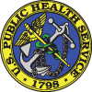JOAG Membership Committee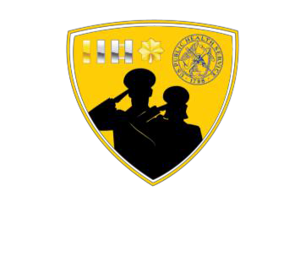

Mission: Facilitate the annual selection of JOAG Voting Members through the nomination and appointment processes outlined in Article VI of the JOAG Bylaws and increase the general membership of JOAG.

# Committee Co-Chairs:

* LCDR Laura McCluney ([Laura.mccluney@ihs.gov](mailto:Laura.mccluney@ihs.gov))
* LCDR Colin Smith ([Colin.smith@ihs.gov](mailto:Colin.smith@ihs.gov))

# SUBCOMMITTEES

## Strategic Liaison:

Ensure that the activities of the Membership Committee are reflected in the JOAG strategic plan by facilitating the annual update for the Membership Committee section of the JOAG strategic plan

## Standard Operating Procedures (SOP):

Reviews and updates the JOAG Membership Committee’s SOP, as needed, for consistency and formatting.

## Social Media:

Relays JOAG membership related information and social media needs to the JOAG’s Communications and Publications Committee.

## Voting Membership:

Facilitates the annual selection of new JOAG voting members.

## Meet & Greet:

Organizes and develops opportunities through which junior officers in a city/region can be introduced to JOAG, learn about JOAG volunteer opportunities, network, discuss issues relating to the Commissioned Corps, and be provided with professional support and advice.

## Listserv:

Maintains a spreadsheet of JOAG listserv members, and coordinates with the Meet & Greet and Officer Involvement and Outreach Subcommittees to ensure that new and interested officers are added to the JOAG listserv and receive information on JOAG opportunities.

## The Committee also includes:

* Co-Secretaries (two)
* Strategic Liaison
* Webmaster

**Please visit our JOAG Membership Committee Website for more information:** (<https://dcp.psc.gov/osg/JOAG/committees_membership.aspx>)