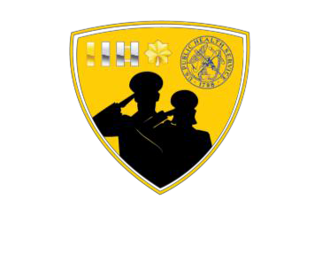JOAG Recruitment and Retention Committee

Mission: Develop projects and programs that aid in the recruitment and retention of junior officers in the United States Public Health Service.

# Committee Co-Chairs:

* LCDR Nazia Rahman ([Nazia.Rahman.mil@mail.mil](mailto:Nazia.Rahman.mil@mail.mil))
* LCDR Adam Loyson ([ALoyson@bop.gov](mailto:ALoyson@bop.gov))

# SUBCOMMITTEES

## Commissioned Officer Student Training & Extern Program (COSTEP) Connection:

Reviews mentoring resources and coordinates the JRCOSTEP/SRCOSTEP mentoring program through mentor matching, participant surveying, and ensures high-quality mentorship interactions.

## Publications:

Recruits authors, brainstorms articles, and publishes on various activities of the Recruitment & Retention Committee as well as additional information that may be valuable to junior officers in the Junior Officer Chronicles (JOC).

## Social Media:

Builds JOAG’s social media branding, promotes JOAG activities and events, increases viewer engagement, and shares credible content relevant to junior PHS officers.

## Retention:

Identifies trends for early separation (service of less than 20 years) through surveys and creates resources/interventions to help retain PHS officers where early separation is preventable.

## Transitional Assistance Program (TAP):

Connects with Department of Defense installations that host Transitional Assistance Program activities and provides information about career opportunities with the USPHS to qualified active-duty personnel from other uniformed services that are in the process of separation.

## The Committee also includes:

* Co-Secretaries (two)
* Strategic Planning Liaison
* Website Coordinator

**Please visit our JOAG Recruitment and Retention Committee Website for more information:**

(<https://dcp.psc.gov/osg/JOAG/committees_recruitretain.aspx>)