Why Mentoring is Important to Career Success
The purpose of the 30-minute webinar is to provide a comprehensive understanding of how mentoring contributes to career success. The panelists offer insight and suggestions gained from their experience on the Career Development Subcommittee Mentoring Project.
These presentations will be available for review by selecting the play recording link (Click Here). The link will also be available on the NPAC website. Please tell us how you liked the webinar by completing an anonymous one (1) minute survey using the following link: (https://www.surveymonkey.com/r/DKLGRR5)

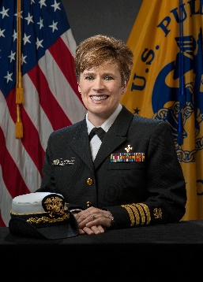
CAPT Amy Valderrama, PhD, MSN, BSN, ACNP-BC
Nurse Epidemiologist (Supervisory), Deputy Team Lead
Centers for Disease Control and Prevention (CDC), Division of Health care Quality Promotion – Atlanta, GA

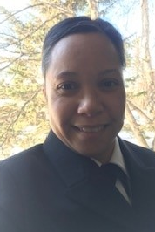
CDR Jazz Fajardo, MSN, BSN, CPN
Senior Nurse Mentor
Indian Health Service (IHS), Southcentral Foundation– Anchorage, AK

CDR Amy Fuelling, MSN, BSN, CPHQ, CPHRM
Quality Assurance Nurse Manager
Indian Health Service (IHS), Southcentral Foundation– Anchorage, AK

