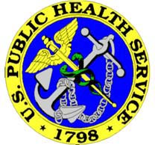 U.S. Public Health Service 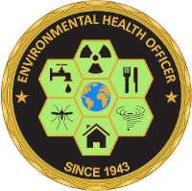
Environmental Health Officer Professional Advisory Committee (EHOPAC)

RAE: RECRUIT AN EHO

Enrollment Form to Participate in the Adopt-A-School or Event Recruitment Program

LAST Name
FIRST Name
PHS #
RANK

Status (check one)

Active Duty Retired

OPDIV/Agency
Work Address
City
State
Zip
Work Email
Work Phone
Work Fax

Are You Basic Ready?
Yes No

Have You Earned The Commissioned Corps Training Ribbon?
Yes No

Please indicate which university(s) or university event(s) you are interested in visiting for recruitment activities.

University | City, State | Did you graduate from this school? (check one) | Do you frequent this geographic location? (check one) | Do you already have an established contact with the program? (check one)
 |  | Yes  No | Yes  No | Yes  No
 |  | Yes  No | Yes  No | Yes  No
 |  | Yes  No | Yes  No | Yes  No

Or,

Please indicate the event(s), location, and a brief description of the event you are interested in attending for recruitment activities.

Event Type | City, State | Event Description

After completing this form, please save as a WORD document and e-mail to the following:
Adopt-a-School: LCDR Dustin Joplin (dustin.joplin@ihs.gov)
Event Recruitment: LT Kate Pink (Kathryn.pink@ihs.gov)

