Engineer Professional Advisory Committee (EPAC)
Voting Member’s Meeting
- Meeting Information
Date: July 11, 2019
Time: 3:00 pm to 4:22 PM

Meeting Link: https://epawebconferencing.acms.com/epac/

Teleconference # 202-991-0477;5277657#

- Agenda
Agenda Items | Speaker | Time
Welcome and Introductions | CDR Russell | 5 min
DSG more active role in coordinating with PACs and special interest groups | RADM Dieser | 10 min
EPAC Task Status | CDR Gumapas | 10 min
Events | LCDR Diana Wong | 5 min
Readiness | CDR Frank Chua | 5 min
Recruitment and Retention | LCDR KC | 5 min
Rules | CDR Spindel | 5 min
Liaison Reports | LT Velasco  CDR Sauer  CDR Thakur  CDR Savalia | 10 min
EPAC Vote  - EPAC SOP Template  - LOA Template  - CDS Update | CDR Russell  CDR Cox | 10 min
EPAC Vote | CDR Spindel | 5 min

- Attendees

- LCDR Julia Kane
- CDR Leo Gumapas
- LCDR Theresa Grant
- LCDR Diana Wong
- CDR Samuel Russell
- CDR William Fraser
- CAPT David Harvey
- CDR John Kathol
- CDR Shane Deckert
- LT Derrick Buck
- LCDR Matthew Palo
- LCDR Jitendra Virani
- CDR Sean Bush
- CDR Eric Hanssen
- CDR Samantha Spindel
- CDR Deborah Cox
- CDR Joshua Sims – LCDR Omobogie Amadasu Alternate
- Minutes

Welcome and Introductions

- DSG more active role in coordinating with PACs and special interest groups
- Planning to meet with PAC Chairs and CPOs quarterly
- Meeting with DSG 2 weeks ago and useful
- Coordination with EPAC Recruitment and Retention and Readiness
- Increase role for Engineers in deployment
- Open line of communication with DSG
- DSG request link for EPAC charter
- More focus on AMSUS and assigned LT Buck and LCDR Wiyor to liaison between EPAC and AMSUS committee
- More coordination with SAME and ways to better serve
- Congratulations to officers that got promoted

Return to Agenda

Chief Professional Remarks
- 27 chartered advisory groups currently
- Efforts are to look at chartered advisory and see connection with OSG
- PAC works on behalf of SG
- PACs are afforded this communication through DSG
- Communication has been through CPO historically
- RADM Dieser supports fully PACs directly communicating with DSG
- There will be changes from OSG on what PACs will be asked to do with guidance from CPOs
- Dependent on tasking from SG some PACs will be tasked more or less
- Any material released from PACs will be behalf of OSG
- CPO board is working on revised charter based on DSG comments
- Unsure of DSG coordination plan
- Increased involvement with AMSUS is based on charter back during 1900s
  - Formal relationship between USPHS and AMSUS
- Still moving forward with relationship with SAME
  - Examining virtual posts for remote areas
  - Provide feedback on what is needed regarding resources
  - Lunch and learn
- Deployment
  - Representative from CDR Degrange and meeting with Army Corps of Engineers
  - Coordination with response efforts with Stafford Act
  - Fantastic event
- Number of outstanding engineers exceeds the promotion slots
  - Continue to remain focused on future and continual development

Return to Agenda

EPAC Task Status
- CDR Thakur to organize a meeting with CDR Sauer, RADM Dieser, and CDR Russell to discuss how to increase USPHS Visibility in SAME TME.

Return to Agenda

Events

- AMSUS 2019:
  - December 2-6th
  - Hosted at the Gaylord Nation Resort and Convention Center (Maryland)
  - Registration is now open
  - The working agenda, rates, and attendance justification statements can all be found on the website (https://www.amsus.org/events/annual-meeting-2/)
  - ​Leads are LT Derrick Buck and LCDR Hanniebey Wiyor
- E-Week Awards Ceremony 2020
  - Hosted at FDA and led by LT Timothy Martin.
  - The event is tentatively scheduled the week of February 16th. ​
- SAME JETC 2020:
  - Team lead is Officer Benjamin Marnell.
  - May 27-29th
  - Hosted in Washington DC
  - Highly anticipated and encourage all engineers to attend
- Cat Day 2020:
  - Hosted in Phoenix, Arizona.
  - June 15-18th
  - ​Solicitation for presentations will start this Fall
  - ​Now recruiting for volunteers
  - Team leads are LCDR Fred Kelly and LCDR Matthew Palo for any additional questions.
- Contact Events Subcommittee Chairs (LCDR Wong or LT Buck) if you would like to volunteer or have ideas to share. Feel free to contact team leads as well.
- ​Updated policies for the Events Subcommittee are anticipated to be completed by the end of the calendar year.
- Thank you to everyone who assisted with Events in 2019!

Return to Agenda

Readiness

- Last RDS subcommittee met on 5/31/2019 at 0830 Pacific.
- Submitted Engineer Deployment Team Roles Fact Sheet to EPAC chair for comments
  - Received minor comments and awaiting further comments from CPO and the rest of EPAC members.
- USACE Training – Disaster Response workshop on June 11-13 in Buffalo, NY.
  - Training was attended by LCDR Omobogie Amadasu.
  - Awaiting debrief from LCDR Amadasu.
    - Include CDR Degrange and highly encourage she participates
- Next RDS meeting will be on July 26th at 0830 pacific.

Return to Agenda

Recruitment and Retention

- Communication Group – Coordinating with Career development subcommittee to explore an opportunity to update PHS Engineering Handbook
- JRCOSTEP- timing of the announcement was the major hurdle to recruit JRCOSTEP.
- 7 Candidate still looking to find the position. Their application will expire soon.
- Connector’s Program – Status of 2017 and 2018 Cohort.

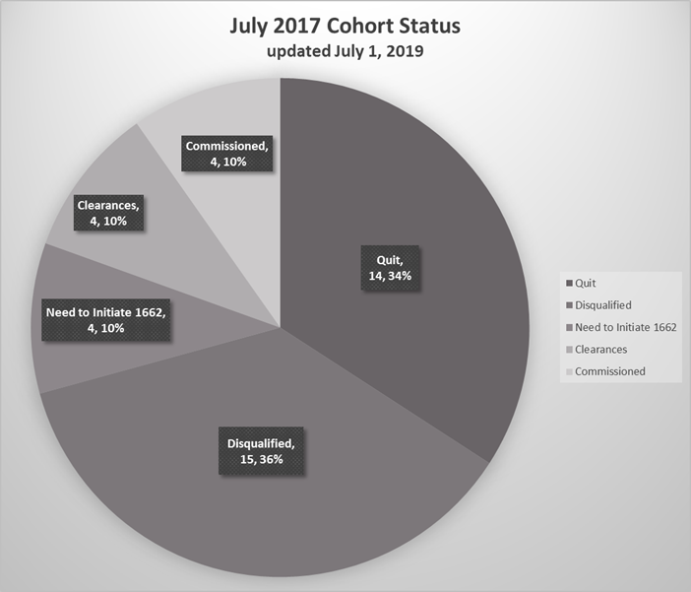
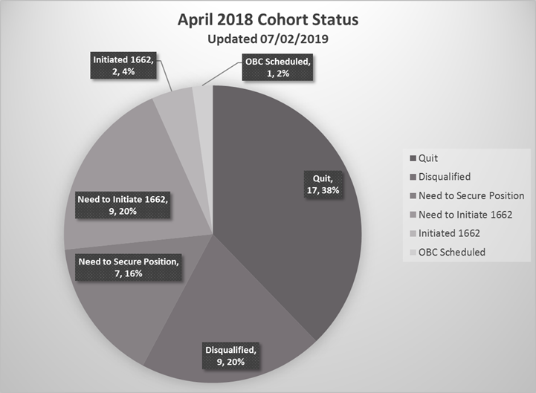
- Level of effort that should be reflected by CCHQ – CAPT Harvey

Return to Agenda

Rules
- Acknowledged receipt for all EPAC voting member nominations. Will begin review of nominations by former EPAC Chairs with tentative selections by end of July.
- Awaiting response from Bylaws Team regarding next steps
- Letter of Appreciation and Standard Operating Procedure templates to be voted on at next meeting

Return to Agenda

Liaison Reports

CCWIAB
- USPHS Symposium 2019 CCWIAB Participation
  - CCWIAB-WLSG joint booth
  - Two abstracts were submitted from CCWIAB (CCWIAB Overview, Breastfeeding Policy Review and Survey)
- Pregnancy Committee
  - PHS Resource Guide for Officers Getting Married or Divorced, or for Dependents Surviving the Death of an Officer (version 2.0 and updates)
  - Updates to the PHS Expectant Parents Resource Guide
  - Draft Worker Hazards Assessments Recommendations
  - PHS Resource Guide for Pregnancy Loss
  - Breastfeeding policy proposal
  - Pregnancy and Postpartum: disqualifying conditions during medical review for commissioning
- Outreach and Membership Committee
  - CCWIAB participation in OBC Open Houses – volunteers needed
  - EHO, Nurse and Scientist category liaison will be rotating off
- Health and Wellness Committee
  - Footwear Research – uniform shoe options white paper
- Resource Guide for officers who are diagnosed with or who are survivors of cancer
- Hair Regulations Policy Proposal
- Caring for disabled family members Guidance of Interest for new development
- Anti-Harassment Committee
  - Path forward for discussion
  - CCHQ on an Anti-Harassment Policy Review

- Website http://dcp.psc.gov/osg/ccwiab/
- Reach out to CDR Savalia if interested in joining - Varsha.Savalia@fda.hhs.gov

COA
- No further update
- Summer picnic this weekend
- 2nd most represented category Engineers – reach out to LCDR Simpson (Michael.Simpson@fda.hhs.gov)

Return to Agenda

EPAC Vote

- EPAC SOP Template
  - 17 – Yes
  - 2 – Absent
  - 1 - Abstain

- LOA Template
  - Make logo consistent between LOA and EPAC SOP
  - 17 – Yes
  - 2 – Absent
  - 1 - Abstain

- CDS Update
  - 17 – Yes
  - 2 – Absent
  - 1 - Abstain

EPAC to vote to approve a Career Development Subcommittee initiative to edit the Engineer CV Cover Page, CV and Instructions found on the EPAC website. We are not seeking to change the format, just to correct inconsistencies and outdated material.
As some background, Rear Admiral Dieser, our CPO, wrote a White Paper titled Engineer Promotion Board Feedback. He met separately with each of the Engineer promotion boards from 2016-2018 to discuss whether the Engineer Category CV template required a change. The boards found no need for the format to change to match the order of the precepts, the key element was its usability – consistency and how readily board members could locate content.
An example of an inconsistencies the CDS proposes to correct is the fact that on the EPAC website the CV template is labeled as CV Cover Sheet Example Format and when you click on the pdf, the title is CV Summary Sheet yet on the CCMIS website the Promotion Checklist refers to a CV Cover Page. CDS proposes to make the title the CV Cover Page. In addition, the Engineer template date is 2012 and mentions OFRD Basic Readiness Standards. CDS proposes to make the examples more current and useful to Engineers including reference to RedDOG and items such as the Commissioned Corps Training Ribbon, Presidential Unit Citation and Humanitarian Service Medal and ensure the documents correlate to each other.

Return to Agenda

Adjourn
- August 8, 2019 meeting on EPAC will be scheduled
- Guidelines will be updated as long as EPAC report outs

Return to Agenda

