EPAC Information Subcommittee

Navigating APAN

# Create an account

1. Login / Password is required. Create an account on apan.org
2. Once you create your account, email the APAN Manager and we’ll add you to the EPAC Sharepoint User or Owner Group.
3. To access the EPAC APAN Sharepoint site:

* Once your account is created, click on the APAN logo circled below
* If the site already recognizes your login, click on your Name in the upper right corner > click My Community Profile

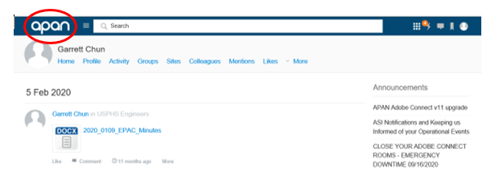

# APAN Sharepoint

As of Sept 23, 2023, APAN will begin to use Sharepoint 2019.

# Recommended Internet Browser

As of 1/13/2021, EPAC Info recommends to use Windows Explorer because it allows for multiple file uploads. Windows Edge and Google Chrome do not allow this.

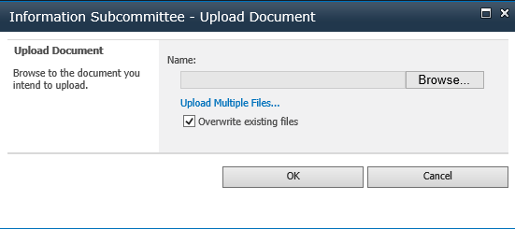

Above Microsoft Explorer (note the Upload Multiple Files)

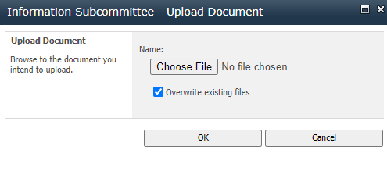

Above Google Chrome without the Upload Multiple Files option

# How to Upload Multiple Files

1. Use MS Explorer
2. ActiveX Filtering must not have a “Checkmark”. Go to upper right Settings Cog > Safety

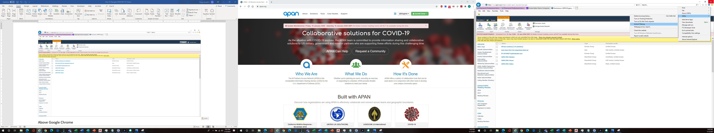

1. Go to Settings Cog > Manage Add-Ons. In the Show Bar, show “All add-ons”. Under the Microsoft Corporation heading, ensure that the STSUpld.Upload.Ctl is Enabled

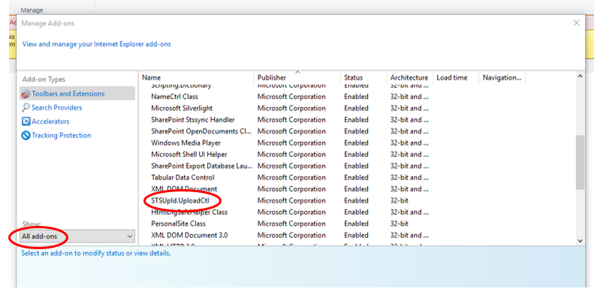

4. If you still cannot upload multiple files, the APAN tech support said it is likely because your Agency IT is preventing you from doing so.

# Navigating to the EPAC Sharepoint Site

In the search bar, type in “USPHS Engineer”

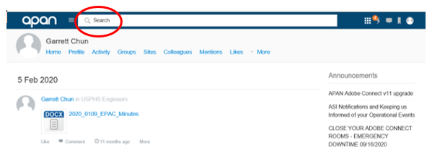

There should be two USPHS Engineer options.

The Teligent site is a Facebook-esque site. It is currently not being used.

The other option is a Sharepoint site used for file archival/storage.

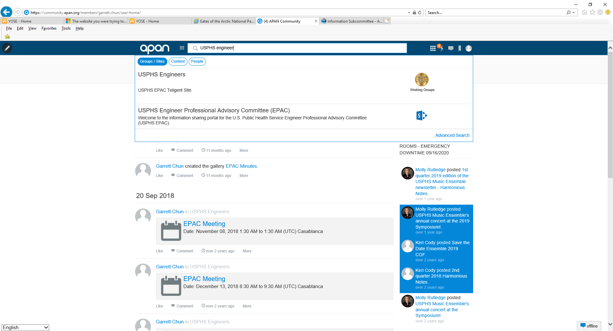

Alternatively you can click on the “Sites” button on the homepage and you should see the Sharepoint site there.

