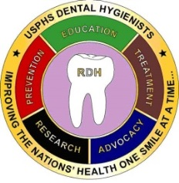 ***The Fulcrum***

***DHPAG Newsletter***

Note from Past DHPAG chair

Note from DHPAG Chair

Note from DHPAG chair elect

DHPAG Executive Committee Chart

DHPAG Executive Committees

DH Awards article and applications

RR& R Subcommittee

Latasha Turner inspirational article-OBC

Dental Hygiene Coin

C0-Editors

LCDR Tammy Thomason

LCDR Kelli Shaffer

Issue I Date Feb 2017

**Note From DHPAG Past Chair** by:

LCDR Sheila Weagle, DHEd, MPH, RDH, CHES

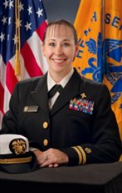

Our HS PAC is undergoing a reshaping process and I would ask for everyone’s patience as we move through this process. There will be more updating overtime and flexibility will be needed for all PAGs not just ours. J LCDR Angelica Chica and I have tried our very best to disseminate all communications from the CPO and HS PAC in a timely manner. However should you ever have any questions, please feel free to ask.

As always, I would like to challenge my fellow dental hygienists who are not part of this superb organization to begin participating with us on our teleconferences and become involved in one of our subcommittees. We are constantly looking for fellow hygienists who are motivated to improve our standing in the Commissioned Corps, serve fellow hygienists, and represent our category with distinction.

As my time as your DHPAG Chair comes to an end, I would like to thank all of the voting members, subcommittees, and the subcommittee chairs for being a wonderful supporting cast. For all your hard work and having to put up with me, I sincerely say, “Thank you” to each and every one of you. You have done so well that the DHPAG leads the way in the HS PAC!

A very special thank you to not only the DHPAG Co-Chair LCDR Angelica Chica but to an amazing friend. LCDR Chica and I have known one another for over 12 years and I know she will move our PAG forward in so many ways. I appreciate all of the times that she has filled in for me while I was out. LCDR Chica has several creative ideas and SO MUCH ENERGY that I look forward to the great movement of the DHPAG.

I was very proud to serve as your 2016 DHPAG Chair!!

Sheila

**Greetings from LCDR Angelica Chica, RDH, BASDH, MPA**

**2017DHPAG Chair**

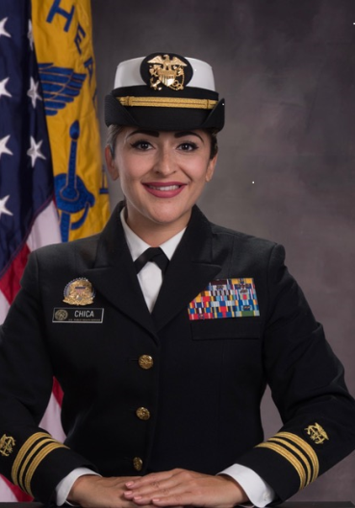

I am very humbled to be serving alongside you as the new DHPAG Chari for FY 2017! This is a great honor and a privilege and I have big shoes to fill. A huge thank you to everyone that has participated in our PAG as a VM, Chair, Co-chair, or volunteer! We are going to continue with the momentum that LCDR Weagle has set as our foundation and move forward with accomplishing our mission together as a family. My believe is the following: It doesn’t matter what your title is or if you are VM or not, what matters is that you contribute and participate in our PAG. We are a family and as such we will continue to call-in/meet bi-monthly to feel the pulse of everyone’s efforts from the boots on the ground doing clinical work to those of us who are no longer in that realm so that we can all have an idea of what we are doing and how we are doing it is collectively contributing to the mission of the Commissioned Corps. I look forward to working alongside all of our members in FY 2017.

**Greetings From LT Ruth A. Williams, RDH, BASDH, MHA**

**DHPAG Chair-Elect**

Hello My Fellow Dental Hygiene Colleagues,

I am so pleased to be able to have an opportunity to contribute to and help support our PAG. Let me begin by letting everyone know a little bit about myself. I have 2 beautiful children (ages 8 and 10) and have been married for 18 years to my high school sweetheart. I began my career by joining the Air Force in 1998 as a dental assistant. During my 12 years of service in the Air Force I had great opportunities to go school and was awarded a scholarship to become a dental hygienist. While in hygiene school I became aware of USPHS and wanted to become a part of it. Once, I finally got my commission in 2012, I was working for Indian Health Service in Keams Canyon, Arizona on the Hopi Reservation. While there I ended up getting a Master of Healthcare Administration through an online degree program and utilized this opportunity to take my career in different direction and apply for an Administrative position (Assistant Health Services Administrator) with Immigrations, Customs and Enforcement (ICE). My time spent with this agency was a great management and administrative experience and another chance to grow professionally. Now, I am currently working with the Food and Drug Administration (FDA) as an investigator, where I am getting settled in.

I want to thank you for giving me a few minutes of your time to introduce myself and I look forward to getting to know and hear from my fellow hygienist as we move forward this year.

2017 New HS PAC Organizational Chart

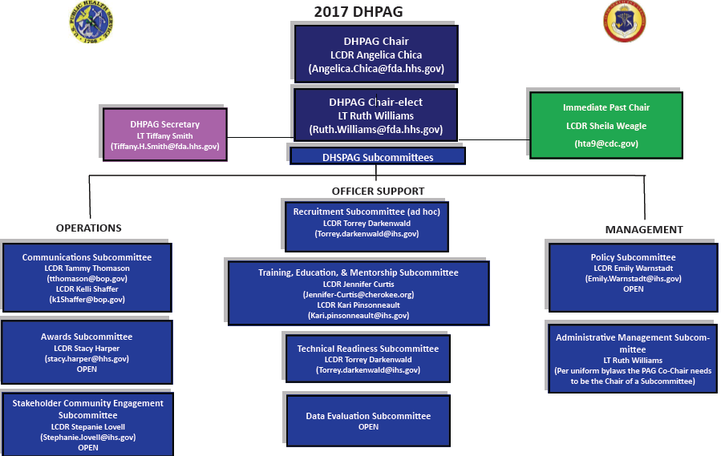

**2017 DHPAG Executive Committee**

**Chair**  LCDR Angelica Chica 305-816-1450 Angelica.Chica@fda.hhs.gov

**Chair Elect** LT Ruth Williams 305-816-1502 Ruth.Williams@fda.hhs.gov

**Secretary** LT Tiffany Smith 520-464-3088 Tiffany.H.Smith@ice.dhs.gov

**SUBCOMMITTEE CHAIRS**

Operations

Communications Chair LCDR Tammy Thomason 304-626-2500 x1151 [tthomason@bop.gov](mailto:tthomason@bop.gov)

Committee Member LCDR Kelli Shaffer 805-735-2771 x 3376 [K1Shaffer@bop.gov](mailto:K1Shaffer@bop.gov)

**Awards Chair** LCDR Stacy Harper 216-767-3490 [stacy.harper@hhs.gov](mailto:stacy.harper@hhs.gov)

Committee Member Open

Stakeholder& Community

Engagement Chair LCDR Stephanie Lovell 405-247-7961 [stephanie.lovell@ihs.gov](mailto:stephanie.lovell@ihs.gov)

Committee Member Open

Office Support

Recruitment Chair LCDR Torrey Darkenwald 406-477-4429 torrey.darkenwald@ihs.gov

(AD HOC)

Committee Member Open

Training, Education &

Mentorship Chair LCDR Jennifer Curtis 918-256-4800 [jennifer-curtis@cherokee.org](mailto:jennifer-curtis@cherokee.org)

Committee Member LCDR Kari Pinsonneault 218-983-6285 [Kari.pinsonnault@ihs.gov](mailto:Kari.pinsonnault@ihs.gov)

Technical

Readiness Chair LCDR Torrey Darkenwald 406-477-4429 [torrey.darkenwald@ihs.gov](mailto:torrey.darkenwald@ihs.gov)

Committee Member Open

Data & Evaluation Chair Open

Committee Member Open

Management

Policy Chair LCDR Emily Warnstadt 509-865-1708 [Emily.Warnstadt@ihs.gov](mailto:Emily.Warnstadt@ihs.gov)

Committee Member Open

Administrative Management

Chair LT Ruth Williams 305-816-1502 [Ruth.Williams@fda.hhs.gov](mailto:Ruth.Williams@fda.hhs.gov)

Committee Member Open

Awards Article by LCDR Cynthia Chennault, RDH, BSDH

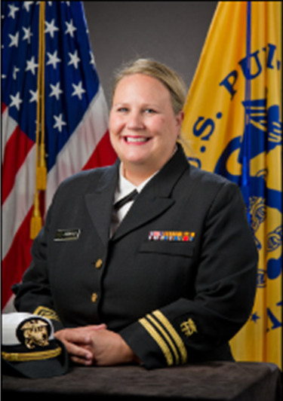

**Importance of Awards** It is important that we take the time recognize our fellow Commissioned Corps dental hygienist for all their accomplishments. Awards are more than just measuring success. Awards have significant impact on an officer’s career and allow you and your accomplishments to stand out and be more visible. They speak volumes about an officer’s service, impact, and accomplishments. Dental hygiene awards are a testament to an officer’s work ethic, dedication, and unique specialty. Every year the Dental Hygiene Professional Advisory Group (DH PAG) awards two dental hygiene officers for their outstanding contributions and significant impact in the advancement of public health. I want to take a moment to discuss the two dental hygiene awards in a little more detail, how voting members evaluate nominees, and the functions of the awards process.

**Candace Jones Award** The Candace Jones Award was named in honor of Captain Candace Jones for her service and commitment to improving the oral health of underserved populations as well as her dedication to the USPHS. Captain Jones was the first dental hygienist to be commissioned in the USPHS. She began her career working with Indian Health Service and then served a short detail to the Health and Resource Service Administration. CAPT Jones was instrumental in establishing dental hygiene as a profession in the USPHS. She developed the commissioning standards and billets for dental hygienist under the HSO category. She has served as the chair for HSO PAC, chair of the Council on Public Health for the American Dental Hygienists’ Association and elected President of the American Association of Public Health Dentistry.

Eligibility requirements for the Candace Jones Award include at least one year of service in the USPHS and require that you be a non-voting member of the DH PAG. Nominees are evaluated on four categories: Career Progression, Award History, Leadership Attributes, and Certifications/Continuing Education. Applicants should demonstrate a history of increasing job responsibilities. This may include dental hygiene related responsibilities, contributions to the local, regional, or national level, or other collateral duties that enhance the mission of the agency and the USPHS. The candidate should have a PHS Training ribbon and at least one other Commissioned Corps individual honor award. Nominees that have other Agency/PHS awards or other professional awards are encouraged. The candidate should have strong leadership qualities demonstrated by membership or leading committees, task forces, or other groups that enhance Agency and/or USPHS mission. The candidate should demonstrate continuous learning evidenced by continuing education in the profession. This can include education in clinical hygiene, public health, program management, or other topics that advance the goals and mission of the USPHS.

**Junior Dental Hygienist of the Year** The Junior Dental Hygienist of the Year Award recognizes a Dental Hygiene Commissioned Corps officer at the rank of O-4 and below. The nominee must have had one full year of service in the USPHS and not have applied for the Candace Jones Award in the same year that they are applying for the Junior Dental Hygienist of the Year Award to meet eligibility requirements. The Junior Dental Hygienist of the Year applicant is evaluated on four criteria: Contributions, Responsibilities, Leadership, and Professionalism. Contributions are measured on impact, either on a local or national level. The candidate must have demonstrated noteworthy contributions to the advancement of public health. Nominees are evaluated on responsibilities by their accomplishments that are above and beyond their usual day-to-day duties. The applicant must also exemplify leadership skills by motivating others towards agency goals and mission or developing new programs or work initiatives. Also, candidates need to maintain professional credentials and demonstrate involvement within the dental hygiene profession and/or community organizations.

**Responsibilities of the DH PAG Awards Subcommittee Chair** There is a great deal of planning and preparation that is involved with the functions of the awards process. Most of the labor occurs at the beginning of the year when awards is in full swing. The process begins by the opening of the application cycle and ensuring that the DH PAG communications committee is involved in distributing the announcements of eligibility and application requirements, along with the deadline submission date. Once applications are received, confirmation emails go out to the nominees and application packages are immediately redacted for the voting members of the PAG. Voting members traditionally have two weeks to evaluate nomination packages and resubmit to the awards committee for final scoring. I say “typically”, because one year voting members only had about a week to review nomination packages to ensure our winners were announced in the Commissioned Officers Foundation (COF) booklet, for the symposium. That brings me to the next step in the awards process. After carefully calculating and reviewing voting members’ scores, winners are announced and notified. This announcement comes across the DH list serve through the communications committee and the awards subcommittee is responsible for notifying the winners and distributing letters to all applicants. The winners are then asked to submit a photo in uniform and verify attendance of the current year’s COF Symposium. Next award plaques are ordered and delivered to an HSO point of contact for presentation during the HSO Category Day Awards Luncheon. This year after the 2016 awards cycle was complete, the Awards subcommittee elicited feedback from the voting members of the PAG to help with improvement of the awards process and to see what can be done to increase nominees. The Awards subcommittee develops and conducts a Questions and Answers (Q&A) Session at the end of the year to encourage dental hygienist to apply for DH PAG awards and to answer any questions.

It has been a tremendous honor and accomplishment to serve these past 3 years as your Dental Hygiene Awards Subcommittee Chair. Serving has given me great insight to the inter-working relations of our PAG. I was grateful to have the opportunity to see the awards application process from beginning to end. I have had the extraordinary privilege of working with the best group of fellow Dental Hygiene Commissioned Corps officers who have continually raised the bar and supported our PAG with pride and distinction. I would highly encourage all Commissioned Corps Dental Hygienists to support and get involved with the DH PAG and especially apply for DH PAG Awards. The opportunity to encourage and build fellow officers up, as well as the joy and satisfaction gained in return are well worth the investment.

**DENTAL HYGIENE PROFESSIONAL ADVISORY GROUP**

**The 2017 Junior Dental Hygienist of the Year Award**

**Nomination Form**

**https://dcp.psc.gov/osg/hso/pags-dhpag-awards.aspx**

Rank/Name:

Position Title:

Work Address:

Work Phone:

Email:

Nominated by:

Rank/Name/Title:

Work Phone:

Email:

Relationship To Nominee:

**Email the cover sheet, Narrative (which addresses the four criteria provided), and CV (HSO Format) in a Microsoft Word Document and NOT Adobe to:**

**LCDR Stacy Harper at** [**Stacy.Harper@hhs.gov**](mailto:Stacy.Harper@hhs.gov)

**Completed nominations must be received by COB February 24, 2017**

(Incomplete nominations will not be considered)

**All nominees must meet and maintain Readiness Standards throughout the year.**

The Junior Dental Hygienist of the Year Award

**Eligibility:**

Any Commissioned Corp Dental Hygienist at the rank of 0-4 and below, with at least one year of service in the USPHS at the time of award submission, is eligible. Candidates may self-nominate. Dental Hygienists who are current voting members of the DHPAG Executive Committee are ineligible during their term with the DHPAG. Also, dental hygienists who are applying for the 2017 Candace Jones Award are ineligible to apply for the 2017 Junior Dental Hygienist of the Year Award.

**Narrative:** Include the following four criteria areas in narrative form.

1.**Contributions**

The candidate has demonstrated noteworthy contributions to public health. The impact can be on either a national or local population.

2.**Responsibilities**

The candidate has shown accomplishments that are above and beyond their usual duties and responsibilities per their billet or job description. Billet/job description would need to be attached.

3.**Leadership**

The candidate demonstrates exemplary leadership in the achievement/contribution being cited. This leadership demonstrates an ability to motivate others towards the attainment of goals, and/or demonstrates vision by developing new programs, work initiatives or projects.

4.**Professionalism**

The candidate demonstrates value to public health as evidenced by such things as professional credentials, demonstrated clinical or administrative contributions, and involvement in professional or community organizations or volunteer activities.

**Evaluation and Selection:**

Health Services Officers serving on the DHPAG Executive Committee will evaluate the nominations and select the winner. Applications must be received no later than COB on February 24, 2017. The winner will be announced during the month of April, 2017. The award will be presented at the annual COA meeting in June 2017. The winner must submit a photo in USPHS uniform and cover any travel expenses to the COA meeting.

**DENTAL HYGIENE PROFESSIONAL ADVISORY GROUP**

**The 2017 Candace M. Jones Award**

**Nomination Form**

**https://dcp.psc.gov/osg/hso/pags-dhpag-awards.aspx**

Rank/Name:

Position Title:

Work Address:

Work Phone:

email:

Nominated by:

Rank/Name/Title:

Work Phone:

Email:

Relationship to Nominee:

**Email the cover sheet, Narrative (which addresses the four criteria provided), and CV (HSO Format) in a Microsoft Word Document and NOT Adobe to:**

**LCDR Stacy Harper at** [**Stacy.Harper@hhs.gov**](mailto:Stacy.Harper@hhs.gov)

**Completed nominations must be received by COB February 24, 2017**

(Incomplete nominations will not be considered)

**All nominees must meet and maintain Readiness Standards throughout the year.**

**Eligibility:**

Any Commissioned Corp Dental Hygienist with at least one year of service in the USPHS at the time of award submission. Candidates may self-nominate. Dental Hygienists who are current voting members of the DHPAG Executive Committee are ineligible during their term with the DHPAG. Also, dental hygienists who are applying for the 2017 Junior Dental Hygienist of the Year Award are ineligible to apply for the 2017 Candace Jones Award.

The nominee must have made a significant contribution in the advancement of the nation’s oral health and to the advancement of dental public health. The nominee must have demonstrated leadership in his/her work and serve as a role model to others.

**Narrative:** Include the following four criteria areas in narrative form.

**1.Career Progression**

The candidate should demonstrate a history of increasing job responsibilities. This may include dental hygiene related responsibilities, contributions to the local, regional or National level or other collateral duties that enhance the mission of the agency and the U.S. Public Health Service.

**2. Award History**

The candidate should have an Independent Officer Training Course (IOTC) ribbon and at least one other Commissioned Corps individual honor award. Additional points will be given for Agency/PHS awards or other professional awards.

**3. Leadership Attributes**

The candidate will demonstrate leadership qualities. Points will be given for membership and/or leadership on committees, task forces, or other groups that enhance the Agency and/or PHS mission.

**4. Certifications/Continuing Education**

The candidate will demonstrate continuous learning as evidenced by continuing education in the profession. Credit will be given for education in clinical dental hygiene, public health, program management, or other topics that advance the goals and mission of the USPHS.

**Evaluation and Selection:**

Health Services Officers serving on the DHPAG Executive Committee will evaluate the nominations and select the winner. Applications must be received no later than COB February 24, 2017. The winner will be announced during the month of April 2017. The award will be presented at the annual COA meeting in June 2017. The winner must submit a photo in USPHS uniform and cover any travel expenses to the COA meeting.

**2016 DHPAG Readiness, Recruitment, & Retention Subcommittee Report**

**By Mylene Santulan**

|  |  |  |
| --- | --- | --- |
| **Goals** | **Target Date** | **Completed Date** |
| Collaborate with the DHPAG Executive Members in the revision of DHPAG RR&R Standard Operating Procedures | Fall 2016 | Not completed |
| Communicate HSPAC Readiness (R) and HSPAC Recruitment and Retention (R&R) Subcommittee Initiatives   * Serve as liaisons to the HSPAC R and R&R Subcommittees      * Attend monthly HSPAC R and R&R Subcommittee meetings | 2016  2016 | 2016 - Attended monthly meetings throughout the year, serving as DHPAG Liaisons to HSPAC Readiness Subcommittee (LCDR Darkenwald) and HSPAC Recruitment and Retention Subcommittee (CDR Santulan) |
| Support HSPAC Readiness Subcommittee and HSPAC Recruitment & Retention Subcommittee Initiatives   * Develop dental hygiene specific recruitment and retention questionnaires to support the 2016 HSPAC R&R Retention Survey * Present the Health Service Assignment Assistance Program (HSAAP) to generate DH volunteer liaisons to assist call to active duty officers (CAD) | Spring 2016  Spring 2016 | 30 August 2016  Submitted the draft of specific dental hygiene questionnaires to HSPAC Retention Survey Lead (CDR Thornton). PAC initiative on hold due changes in PAC  Spring 2016  Presented to the DHPAG group |
| Develop connection with USPHS Agency Liaisons for assignment resources. | Summer/Fall 2016 | 12 October 2016  Goal revised. Instead completed and released the Career Opportunities document to the DHPAG group in October 2016. The document served to support DHPAG members in search of assignments in the Commissioned Corps. The document was not an all- inclusive replacement for USA job, but an extra assignment resource for DHPAG members. |
| Create a dental hygiene survey to determine specific dental hygiene readiness, recruitment, and retention needs. | Summer 2016 | Not completed |

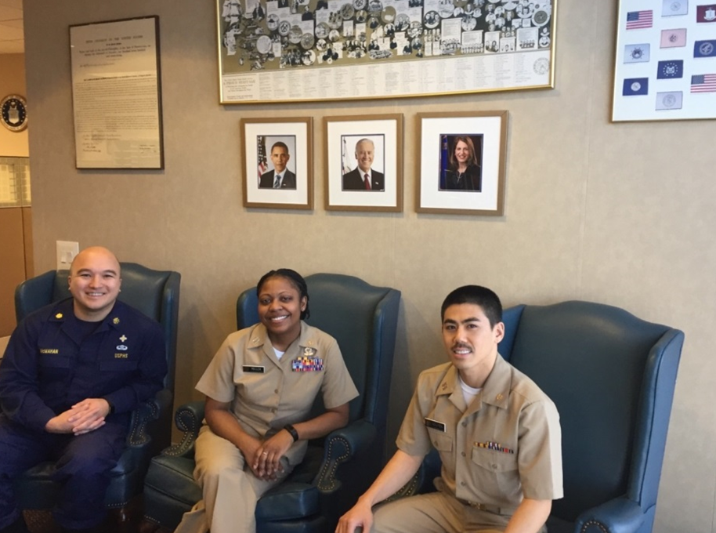

**Dental Hygienists Inspire Through Training**

**By: Latasha A. Turner, RDH, BS**

Rather than spending Veteran’s Day getting a free breakfast this year, I elected to attend an American Eagle continuing education seminar on the Double Gracey. While there, I was excited to learn of the new instrument design which combines the Universal curette and Gracey features into one. American Eagle distinguishes their products by manufacturing the curettes with a patented sharpen-free XP technology.

Sharpen-free? Not having to sharpen our instruments sounds like a hygienist’s dream come true. However, for those of us in the U.S. Public Health Service (USPHS) Commissioned Corps (Corps), staying sharp when it comes to career management is not so worry-free. Fortunately, for Corps officers, the Commissioned Officers Training Academy (COTA) provides a foundation and support to assist officers in learning the skills necessary to stay sharp throughout their careers. The objectives of the Training Academy are designed to increase officer’s knowledge and build skills to support USPHS missions. COTA staff (Cadre) strive to train and inspire Commissioned Corps Officers to lead by example, promote Corps values and be a positive representative for our uniform and Nation’s health.

Since 2014, the COTA Director has selected 3 dental hygienists; LCDR Sean McMahan, LT Tuan Nguyen and myself, LT Latasha Turner through a competitive interview process to become members of the COTA Cadre. Though not in full-time clinical dental hygiene, we are still educating and inspiring, just in a different capacity. The COTA training environment has allowed each of us to continue to provide service to fellow officers, as well as, contribute to the community and USPHS mission with three concepts of instrumentation: stay sharp, do no harm and choose wisely.

**Stay Sharp**

One training that COTA facilitates to help sharpen officers is the Officer Basic Course (OBC). This flagship course indoctrinates call-to-active-duty officers to life in a uniformed service as a PHS officer. During the intensive 2-week training, officers learn customs and courtesies, proper uniform wear, PHS history, basic drill, the importance of team work and accountability, the meaning of PHS readiness, and deployment expectations. As the Corps continues to evolve and advance, process improvements are critical in the forward growth of our service. With the same rigor and enthusiasm as in practice, we incorporated our great organizational and communication skills to improve the course in various ways. LCDR McMahan managed the Learning Management System (LMS) and created a checklist which allows officers to track progress of required action items. With a need for better clarity, I revamped the welcome letter which oriented incoming officers to the LMS and other preliminary actions prior to OBC. With a short handover of COTA Cadre, LT Nguyen recently launched the new CCLMS page (https://usphstraining.hhs.gov/) which improved navigation and better access for Commissioned Officers from recruitment through separation. Together, we made the Corps-wide LMS and COTA website a more user-friendly tool for prospective and incoming officers. Aiming towards building relationships with other academies and ensuring our Basic Training aligned with that of our sister service, the Cadre team visited the US Navy Officer Development School in Newport, Rhode Island. There the instructors had the opportunity to observe instructional methods, training structures, curriculum development and delivery techniques.

As instructors, the Cadre also had the opportunity to gain knowledge and skills in other areas. All three hygienists have been exposed to contracting principles, appropriations, government travel, Moodle (an online learning platform and course management system), and increased familiarity of PHS policies. Both LCDR McMahan and I have received COR (Contracting Officer Representative) certification training. LCDR McMahan has now received his Level II certification. These acquired skills continue to strengthen us and have allowed us to experience other capacities and positions within the Corps.

In order to keep hygiene skills current and hands working, we also continue to provide hygiene services in our communities. By participating in different Missions of Mercy (MOM) projects throughout Virginia, not only do we keep our hygiene skills sharpened and get back into the clinic, vulnerable populations are also served by USPHS Commissioned Corps Officers! MOM projects are one of the most energizing and rewarding experiences. Participating gives us an opportunity to contribute to oral health needs of over 4,000 low-income individuals in 69 localities annually. We are also able to enlighten current and prospective hygiene students on the Public Health Service. LT Nguyen has participated in a global dental relief mission in Nepal and in addition to volunteering in the community, I continue to strengthen my skills by offering hygiene services to the Walter Reed National Military Medical Center Primary Dental Clinic in Bethesda, Maryland.

**Do No Harm**

Unsharpened instruments not only burnish the surface of calculus, it causes strain and pain on our wrists, hands, shoulders, neck and back. These instruments cause physical and mental fatigue. We have to push harder, trying to compensate for the lack of sharpness, spending more time on the same surface and who has ever had those ongoing thoughts of, “I still feel the calculus, I still feel the calculus. Just a little bit more.” In order to prevent possible iatrogenic traumas, we much keep our instruments sharp, engaged and adaptable.

Dull is usually boring and monotonous. During the McMahan and Turner tenure at COTA, the Cadre participated and interacted more with the students. More team building exercises were incorporated into the day and the instructors began joining the “OBCers” for Physical Training exercises. LCDR McMahan began doing group runs while integrating cadence calls and building team comradery with relays as I became known for my energizing circuit trainings and warm-up sessions (choreography credited to the Whip Nae Nae and Wobble dance moves). LT Nguyen has now taken the reigns and is lauded for his Ultimate Frisbee and engaging drill sessions. Classroom interaction remained effective with high-energy, enthusiasm, different response and group activities. Using our experiences of educating our patients on the significance of oral health, providing OHI, consultations, and patient briefings has definitely helped played a role in grooming us for some of our instructor duties.

**Choose Wisely**

We all know too well the importance of utilizing sickle scalers supragingivally and the Gracey 11/12 on mesial surfaces and what sitting positions allow us to best access our focused site. Some instruments are area-specific and if used in the wrong area on the wrong surfaces, will be ineffective in removing calculus…or damaging to oral tissues or structures.

For the COTA instructors, recognizing specific areas of expertise was beneficial to the team. The COTA Chief, senior leadership and other sections called upon us on multiple occasions to work on projects or take part in ceremonies. LCDR McMahan and I were personally requested by RADM Scott Giberson and Acting DCCPR Director to support many of the initial logistics and preparatory activities leading up to the departure of all Monrovia Medical Unit (MMU) teams. While a fellow instructor was deployed to Monrovia, LCDR McMahan and I continued to meet the needs of the Corps. The two of us pulled together to ensure no interruption in the OBC and OMC (Officer Mid-Level Course) trainings or daily taskings in COTA. Eager to follow suit from the other two hygienists, LT Nguyen had to step up shortly after his arrival to assist when I went into labor 3 weeks ahead of my scheduled due date. He quickly grasped the logistical aspects of OBC and began filling in the gaps by instructing and helping out where needed.

Sharp instruments are necessary in dental hygiene as well as throughout our lives (and careers). Bringing our life skills, hygiene skills and experiences has allowed us to grow while contributing value to the Corps. The three of us were able to bring different experiences to the COTA team to improve, inspire and encourage. Something that we do as hygienists every day! Prior to joining the COTA Cadre, LCDR McMahan served as a US Army Ranger and with the Bureau of Prisons (BoP) at FCI Oxford and MCC Chicago. LT Nguyen provided services in an urban clinic in Albuquerque, New Mexico with the Indian Health Service (IHS) servicing tribes across four Southwest states and I began my Corps service with IHS clinics in El Reno, Watonga and Clinton, Oklahoma after serving nearly 10 years as an Air Force dental technician. As hygienists in COTA, we were able to bring our organization skills, communication skills, team building experiences as well as being able to work independently. Being lifelong learners and improving skills are imperative for positive growth and by using our experiences, sharpening our abilities, and remaining versatile, we (hygienists) continue providing value to our Corps, our community and our country.

**HOW MANY WILL TAKE THE CHALLENGE AND BUY A COIN THIS MONTH?**

***Dental Hygiene***

***Professional Advisory Group Coin***

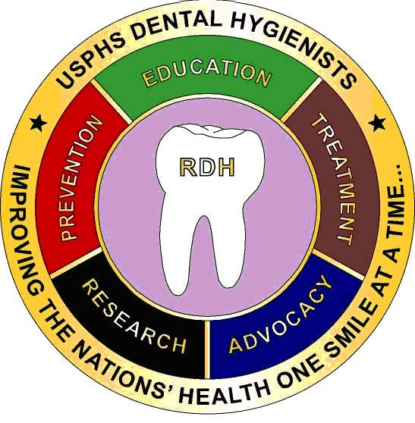

**ORDER TODAY**

LCDR Angelica Chica

**305-816-1450**

**Angelica.chica@fda.hhs.gov**