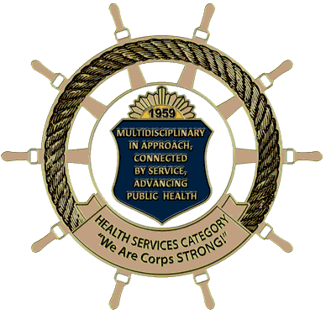

HSPAC Communications Subcommittee
HSO News You Can Use: Biweekly Announcement Submission Form

The HSO News You Can Use is distributed through the HSPAC listserv every other Wednesday.
Announcements will be posted for a maximum of one month. If you would like your announcement to remain in, you must submit a new announcement request. Announcements must be applicable to more than one discipline (PAG).

Steps to Submit:
  - Ensure your HSPAC subcommittee/PAG Chain of Command has approved announcement.
  - Send the announcement to Announcements.HSPAC@gmail.com by 3:00pm EST Friday before Wednesday distribution date. Make sure to copy your HSPAC Subcommittee/PAG Chair on your submission.
What to Submit:
Announcements must use Calibri 10pt font and include the following information:
Note: if you are submitting an event announcement, you must also send a calendar invite to Calendar.HSPAC@gmail.com with all event information included.

Title of Announcement:
PAC Subcommittee/PAG Name/Other:
Point of Contact (including officer’s name, rank & email):
Description (if applicable: include weblink(s) and/or corresponding attachments also sent to Announcements.HSPAC@gmail.com]: Note: 100 word limit; field expands to accommodate text

Questions? Reach out to the HSPAC Communications Subcommittee Chair/Co-Chairs: Communications.HSPAC@gmail.com

