**Professional Advisory Groups (PAG) Logos**

Basic and Applied Science (BASPAG)

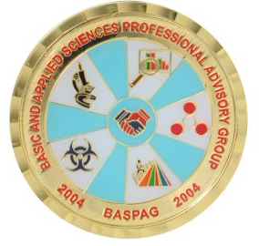

Dental Hygiene (DHPAG)

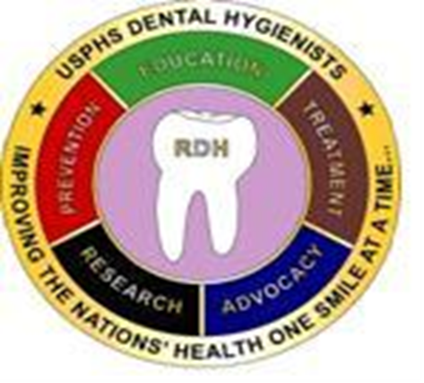

Healthcare Administration (HAPAG)



Health Information Technology (HITPAG)



Medical Laboratory Scientist (MLSPAG)

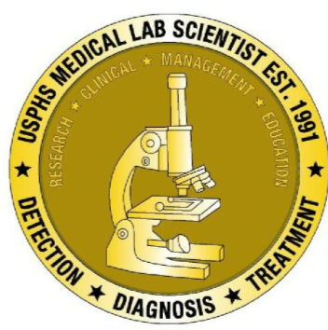

Optometry (OPAG)

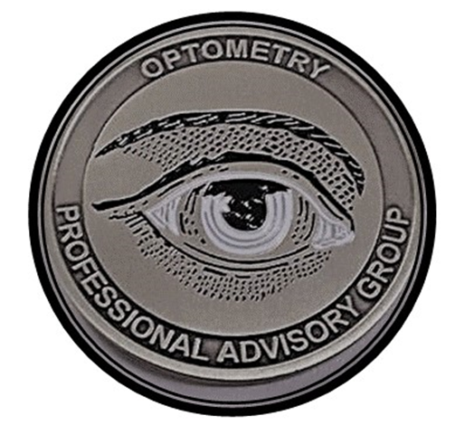

Physician Assistant (PAPAG)



Public Health (PHPAG)

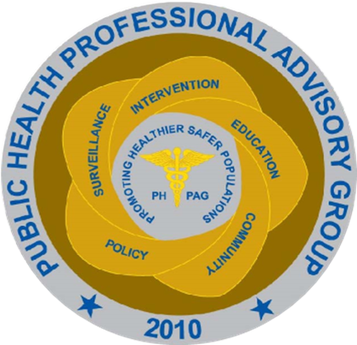

Psychology (PSYPAG)

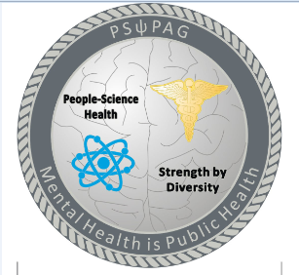

Social Worker (SWPAG)

