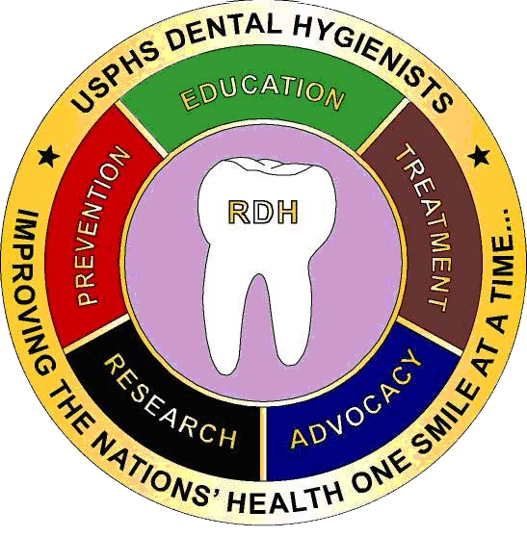 ***The Fulcrum***

Note to DHPAG Chair

LCDR Ruth Williams

2018 Fall Issue III

**Note to Chair**

**Welcome Chair-Elect**

**DHPAG Executive Committee Chart**

**Article Submission –**

**LT Tanya Selling**

**Subgroup Corner**

**Mark Your Calendar**

**Coin Purchase Information**

**Co-Editors:**

**LCDR Marie-Elena C. Puleo**

**LCDR Paula M. Arango**

**Newsletter Submissions:**

[**marie-elena.puleo@fda.hhs.gov**](mailto:Marie-Elena.Puleo@fda.hhs.gov)

**5/2**

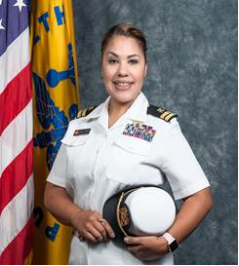

Hello Fellow Dental Hygiene Officers,

Please join me in thanking LCDR Ruth Williams for her dedication and hard work this past year as our DHPAG Chair. We truly appreciate your continued support as we move forward.

Let us welcome and support our incoming 2019 DHPAG Chair, CDR Kari Pinsonneault!

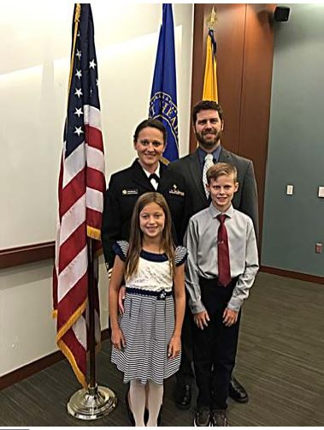

*Welcome Chair-Elect CDR Kari Pinsonneault!*

CDR Kari Pinsonneault is a Health Insurance Specialist and ACA Account Manager at the Kansas City Regional Office-Health Plan Operations Branch. Prior to joining CMS, she spent seven years as the Dental Prevention Officer at White Earth Indian Health Services, and two years as Dental Hygienist at the Department of Homeland Security, detailed at the Port Isabel Detention Center. She is proud to have deployed to the BP Oil Spill response, serving as an epidemiologist out of BP’s corporate office in Houston. She also deployed as the HHS LNO, overseeing patient movement air evacuations out of Scott Air Force Base during the response efforts for Hurricanes Harvey, Irma, and Maria. CDR Pinsonneault served as a Team Leader of unification operations at Port Isabel Detention Center during this year’s UAC Reunification mission. Most recently CDR Pinsonneault was deployed as an HHS LNO at FEMA Region IV RRCC for Hurricane Florence and Scott Air Force Base for Typhoon Yutu. She received her dental hygiene degree from the Medical College of Georgia School of Allied Health. She enjoys spending time with her husband and two children outdoors and traveling.

CDR Pinsonneault will chair the DH PAG during 2019. Her goals during that year are to increase the activity among officers within the PAG. During her years in clinical practice, participating in PAG related activities was challenging, as most of us can agree and attest to. “As the Corps. is rapidly changing, we are going to challenge our PAG to increase their participation so their voices can be heard. Now more than ever we need to be advocating for our profession and our PAG!”

**2018 DHPAG EXECUTIVE COMMITTEE**

|  |  |  |  |
| --- | --- | --- | --- |
| Chair | LCDR Ruth Williams | 305-816-1502 | ruth.williams@fda.hhs.gov |
| Chair Elect | CDR Kari Pinsonneault | 816-426-6472 | kari.pinsonneault@cms.hhs.gov |
| Secretary | LCDR Tiffany Smith | 520-464-3088 | tiffany.h.smith@ice.dhs.gov |

**Operations**

|  |  |  |  |
| --- | --- | --- | --- |
| Communications Chair | CDR Kari Pinsonneault | 816-426-6472 | kari.pinsonneault@cms.hhs.gov |
| Co-Chair | LCDR Marie-Elena Puleo (Lana) | 845-220-2122 x1101 | marie-elena.puleo@fda.hhs.gov |

|  |  |  |  |
| --- | --- | --- | --- |
| Awards Chair | LCDR Tammy Thomason | 304-626-2500  x1151 | tthomason@bop.gov |

|  |  |  |  |
| --- | --- | --- | --- |
| Stakeholder & Community Engagement Co-Chair | LCDR Nicolette Bennett | 301-443-3562 | nbennett@hrsa.gov |
| Co-Chair | LT Latasha Miller | 240-453-6006 | latasha.miller@hhs.gov |

**Officer Support**

|  |  |  |  |
| --- | --- | --- | --- |
| Recruitment Chair  (Ad Hoc) | LCDR Torrey Darkenwald | 406-477-4429 | torrey.darkenwald@ihs.gov |

|  |  |  |  |
| --- | --- | --- | --- |
| Training, Education & Mentorship Chair | LCDR Paula M. Arango | 609-723-1100  x6783 | parango@bop.gov |
| Co-Chair | LCDR Andrew Felix | 619-661-4072 | andrew.felix@ice.dhs.gov |

|  |  |  |  |
| --- | --- | --- | --- |
| Technical Readiness Chair | LCDR Torrey Darkenwald | 406-477-4429 | torrey.darkenwald@ihs.gov |

|  |  |  |  |
| --- | --- | --- | --- |
| Data & Evaluation Chair | LCDR Charles Brucklier | 301-443-0210 | cbrucklier@hrsa.gov |

**Management**

|  |  |  |  |
| --- | --- | --- | --- |
| Policy Chair | LCDR Emily Warnstadt | 509-865-1708 | emily.warnstadt@ihs.gov |
| Administrative Chair | LCDR Diane Weidley | 301-443-8106 | dweidley@hrsa.gov |

My First Presentation  
informing civilians of USPHS

LT Tanya Selling, RDH

“Elevator Speech.” That was the first thought that popped into my head August 2017 when attending my annual CE courses at the 2017 Impact Conference for the Arizona Dental Hygiene Associations’ scientific Conference. During the event I was invited to a small get together, which turned out to be a get together for the Arizona Dental Hygiene Association Chair members. I was the only person there who was not a chair member of the association and one of the youngest ones in the room. All eyes were on me, so when they started asking what private practice I work for and I responded, “I don’t work for a private practice, I am a commissioned officer in the United States Public Health Service”, USPHS, then all the questions started flooding. “USPHS? What is that?” “What do you do?” “How do you become an officer” “What is it like”. I just remember thinking “Elevator Speech.” I am so thankful for OBC teaching us to have an idea of what we would say when that happens. As I elaborated on what USPHS is and what I do as an RDH, one of the members asked me if I would speak at group meeting for, Maricopa County Oral Health Leaders Advocates and Resources, MOLAR, and I graciously accepted.

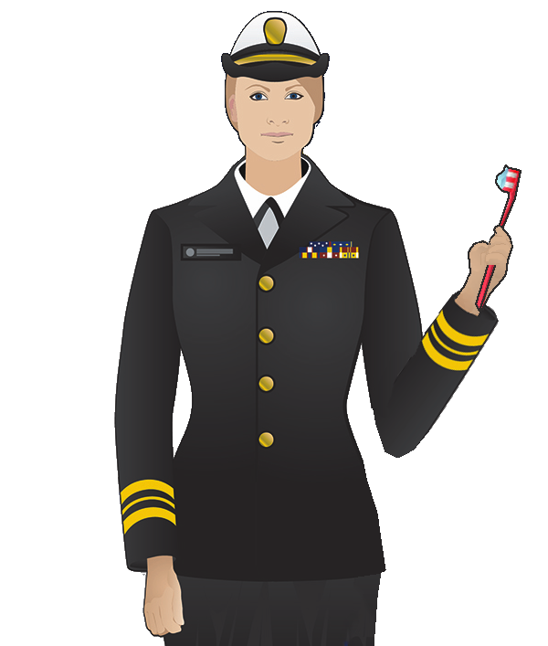The MOLAR Coalition is a dedicated group of concerned providers and social service agencies who are committed to addressing the oral health issues in their community. Their goal is to increase the ability of public and private organizations to improve oral and overall health of their constituents. Typical meetings consist of 20-30 individuals from different professional backgrounds, Dentists, Dental Hygienists, Dental assistants, Physicians, Nurses, Social Workers just to name a few. They come together to discuss the community needs and learn about other avenues of providing health care and interesting topics. MOLAR is very important to our county, as Maricopa county is the fourth largest populated county in the country with nearly 4 million residents including 46 cities, towns, and communities and 5 Indian reservations.

A few months later, I was in the full swing of things acquiring permission from my supervisors, agency and our DHPAG leadership to proceed with the presentation. During the process, I was so thankful for several people who took their time to help me gather information. After gathering all the information, I did some research of my own and began designing the power point presentation based off some of the other formats I saw. A lot of time and effort went into organizing and reorganizing the slides. An average of 10 hours went into editing images, graphics, video clips, researching, sending out surveys, going through previous radiographs for case presentations, practicing, revising, and more time practicing.

Image from USPHS.Gov then minor edited by LT Selling to be more Dental Hygiene related

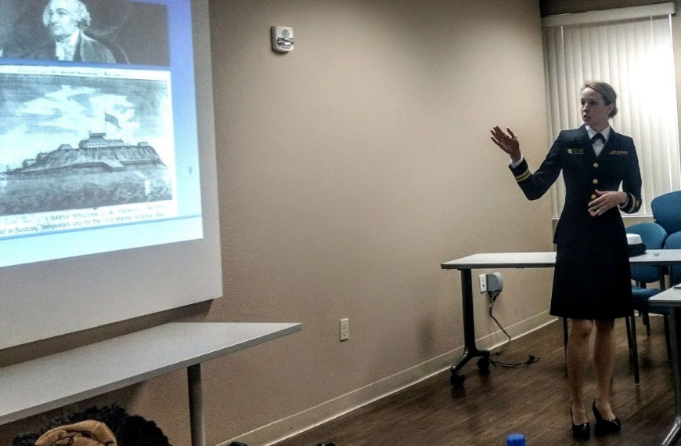Parts of my presentation included personal background, History of USPHS highlighting our impact to national health and disaster responses, Mission and Core Values, Current leadership, where we can work, and who makes up the USPHS what professions. I educated the audience on the HSO Motto “Strength through Diversity” with a diagram showing the current percentage at the time of RDH in the HSO category and the benefits of being a USPHS Officer. That was just my first half of my presentation. The rest of the presentation went over my personal experience working for Immigration and Custom Enforcements, ICE, under the Department of Homeland Security, DHS, and a typical day for me and how it differs from private practice. I touched on the importance of documentation of instruments and sharps and why it is important at a detention center, as well as language barriers. My presentation then went on to show case presentations of things I have seen from patients with all their teeth to no teeth, decay, periodontal disease and injuries such as broken jaws due to a shot gun. From there, I explained what collateral duties are and the importance of not only everything already described but also on outside work participation. I went over some of my own examples of things I am involved in such as, subcommittees, PHS Ensemble, COA, Athletic events, TDYS and deployments. I also included the “typical day” for hygienists in other agencies, BOP and FDA. The presentation was wrapped up with a 1945 video from Tennessee Department of Public Health which was made with the help of USPHS on preventing dental decay.

LT Tanya Selling, Presenting power point, “Serving as a Dental Hygienist in the Commissioned Corps of the U.S. Public Health Service”

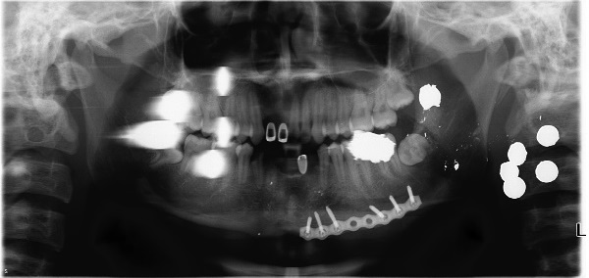After practicing numerous times with the timer, presentation day finally arrived and I was prepared. I arrived at the facility and there were 16 people present for the meeting. The beginning of the presentation was a little bit rocky, the computer system froze and my power point wasn’t working. However, thankfully due to my preparations I was confident and could continue presenting and within a few minutes the computer unfroze. Other than that little hiccup as I started speaking about the History of USPHS and I saw the genuine interests on my audiences’ faces, my anxiety melted away. They were especially interested in the portion of my presentation where I went over what I personally have seen at my ICE facility.

Case presentation.

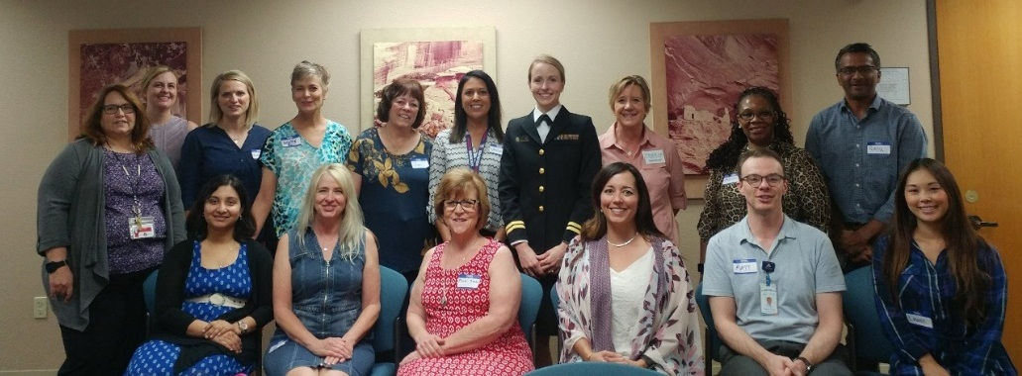The presentation was a success! After the presentation, I had a Physician ask me where he could go to find out more information on how to commission in to the corps, and two local Dental Hygiene instructors ask me to speak at their colleges to their future RDH’s this fall and next spring! I am so thankful for MOLAR and the opportunity they gave me to present.

My takeaways from this experience, always have your “elevator speech” ready; you never know when someone may approach you and ask what USPHS is all about. Secondly, reach out to the DHPAG if you need any help or assistance. I couldn’t be any more grateful for them as well as my other RDH Colleges they are such amazing and helpful people!

LT Tanya Selling, RDH, with the MOLAR coalition members.

During the process of putting together my presentation I was so thankful for several people who took their time to help me. Thank you so much to LCDR Williams, CDR Pinsonnaeult, LCDR Chica, LCDR Felix and LT Woldeamanual for all ya’lls help, guidance and insight into your own “typical” days at your agencies, review and suggestions. Lastly, don’t be afraid to step out of your comfort zone, you may be surprised and find that you really enjoy doing it!

**Subgroup Corner**

**COMMUNICATIONS SUBGROUP**

***WANTED***: Articles for newsletters

***A day in the life of a RDH***

***Alternative Career Paths***

***Upcoming Conferences***

***Volunteer Opportunities and Engagement***

***Community Events***

***Tips for Successful PCS***

***Deployment Experience***

***Kudos for promotions and awards***

What do you want to see in the Newsletter?

**Newsletter Submission Deadlines:**

Issue III Oct 26th

**AWARDS SUBGROUP**

Nothing to report at this time

**STAKEHOLDER & COMMUNITY ENGAGEMENT SUBGROUP**

The ADHA 2019 Annual Conference is in Louisville, KY June 21-23, 2019. Anyone attending next year and is interested in presenting, please contact LCDR Nicolette Bennett at [nbennett@hrsa.gov](mailto:nbennett@hrsa.gov) or LT Latasha Turner at [Latasha.Turner@hhs.gov](mailto:Latasha.Turner@hhs.gov)

**TRAINING, EDUCATION & MENTORSHIP SUBGROUP**

*Promotion Trends, Results, and Preparation Webinar*

Hosted by HSPAC Analytics and Career Development Subcommittees

Friday, November 16, 2018

11:30 am – 1:00 pm

Toll Free: 1-877-465-7975

**TECHNICAL READINESS SUBGROUP**

Reminder that the Readiness website has been updated and if you have any questions for requirements, please contact LCDR Torrey Darkenwald at [Torrey.Darkenwald@ihs.gov](mailto:Torrey.Darkenwald@ihs.gov).

**ADMINISTRATION SUBGROUP**

DHPAG Meeting Date: *December 11th*

**DATA & EVALUATION SUBGROUP**

Nothing to report at this time

**RECRUITMENT SUBGROUP**

Interested in participating in the Advanced Readiness Program?

Next Enrollment dates: November 15- December 15, 2018

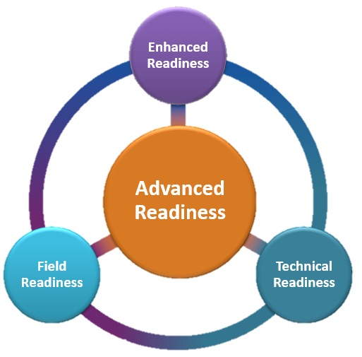

Contact LCDR Torrey Darkenwald

for more information.

[Torrey.Darkenwald@ihs.gov](mailto:Torrey.Darkenwald@ihs.gov)

**POLICY SUBGROUP**

Nothing to report at this time

**Mark Your Calendar**



**The Future of Health Care is Now, 27 Nov – 30 Nov 2018**

**Gaylord Conference Center, National Harbor, MD**

**“127th Meeting**”

[http://www.amsusmeetings.org](http://www.amsusmeetings.org/)



FREE: <https://www.dentalcare.com/en-us>

FREE: <http://vivalearning.com/>



Certified Correctional Health Professional (CCHP): <http://www.ncchc.org/cchp>

Dental Hygiene Professional Advisory Group (DHPAG) Coin Order Form

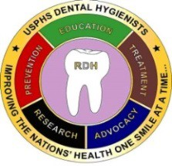 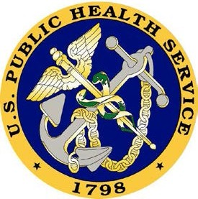

**Price: $12**

Name:

Address (for shipment):

City/State/Zip Code:

E-mail:

Phone:

Quantity:

Total Enclosed: (including S&H) (*Please make the check payable to:* ***Commissioned Officers Foundation****)*

Send your check and this form to: LCDR Angelica Chica

**Shipping and Handling:**

Less than 10 coins= $5.00

10 or more coins= $7.00

U.S. Food and Drug Administration 15100 NW 67th Ave, Suite 400 Miami Lakes, FL 33014

***QUESTIONS: Contact LCDR Chica at 305-816-1450 or [angelica.chica@fda.hhs.gov](mailto:angelica.chica@fda.hhs.gov)***

[angelica.chica@fda.hhs.gov](mailto:Angelica.chica@fda.hhs.gov)