PAPAG Award Requirements

PAPAG Physician Assistant of the Year Award
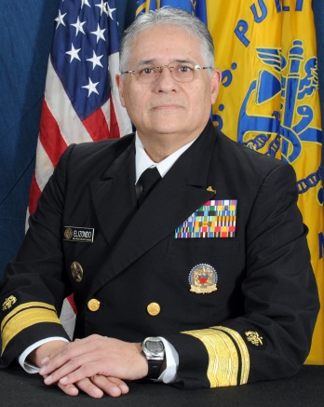
The Physician Assistant Professional Advisory Group (PAPAG) established the PAPAG Physician Assistant of the Year Award in 2005. It is presented to a PHS Physician Assistant who is recognized for outstanding leadership, exceptional clinical contributions and/or exemplary service and accomplishments which positively impact the Public Health Service and Physician Assistant profession.
RADM Epifanio “Epi” Elizondo Physician Assistant of the Year Award
In August 2010 RADM Elizondo was appointed as Chief Professional Officer (CPO) for the Health Service Officers (HSO) category. RADM Elizondo served as the CPO for over five years and implemented numerous policies which have enhanced the capabilities of the HSO category. In August 2012, he was promoted to Rear Admiral (Upper Half) which made him the highest ranking Physician Assistant in the seven uniformed services. Prior to joining the Public Health Service, Admiral Elizondo served in the U.S. Navy, U.S. Army, and the U.S. Air Force. This award is presented to a Senior Grade (O-5 and above) PHS Physician Assistant who is recognized for outstanding leadership, exceptional clinical contributions and/or exemplary service and accomplishments which positively impact the Public Health Service and Physician Assistant profession.

RADM Michael R. Milner Physician Assistant of the Year Award
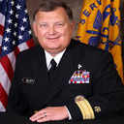
Before receiving his commission in the U.S. Public Health Service in 1989, Milner served in the U.S. Air Force. He is the first Physician Assistant in any uniformed service to achieve the rank of Rear Admiral and holds the title of Assistant United States Surgeon General. As an Assistant US Surgeon General and Rear Admiral in the U.S. Public Health Service, he was responsible for public health programs for the six states of the New England region. He was recognized as the 2012 AAPA President’s Award recipient for his lifetime contributions to the PA profession. The award is presented to a Junior Grade (O-4 and below) PHS Physician Assistant who is recognized for outstanding leadership, exceptional clinical contributions and/or exemplary service and accomplishments which positively impact the Public Health Service and Physician Assistant profession.

Eligibility
Any active duty PHS Physician Assistant commissioned officer may be nominated. One nominee will be chosen each year for the PAPAG Physician Assistant of the Year award. Members of the PAPAG are not eligible.

Award Criteria
Each recipient shall demonstrate one or more of the following activities (or activity) during a current tour of active duty with the PHS. Activities and accomplishments in prior tours, with prior services or as a civilian do not qualify.
- Outstanding, unquestionable leadership in the Public Health Service including but not limited to mentoring and impact with fellow Physician Assistants.
- Clinical excellence evidenced by quality work, improved outcomes with demonstrated and documented impact to patients.
- The application of unique skills or creativity in the approach or solution of a situation(s).
- Contribution or accomplishment which notability impacts and improves public health.
- Professional contributions significant to a division, bureau, agency, community, state, region, or nation.
- Courage and integrity in hazardous, austere or emergency environments.
* All Nominees must meet Basic Readiness Standards
The recipient must meet basic readiness standards. The award will be presented annually at the Commissioned Officers Association meeting.

Nomination Procedure
- The PAPAG may nominate an eligible officer.
- Any PHS employee may nominate an eligible officer.
- Professional colleagues may nominate an eligible officer
- Officers may not self-nominate.
- Nominations must be received annually by midnight, January 31st, 2016.

