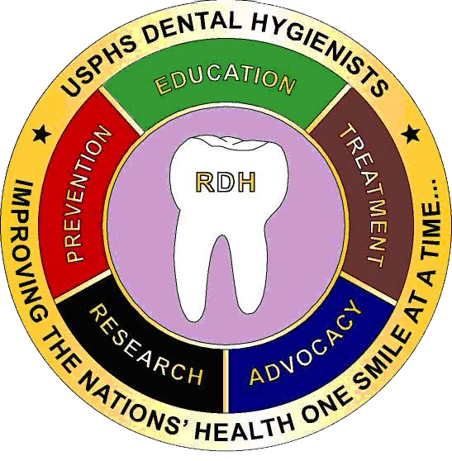 ***The Fulcrum***

Note from DHPAG Chair

LCDR Ruth Williams

2018 Summer Issue II

**Note from Chair**

**DHPAG Executive Committee Chart**

**Article Submission –**

**LCDR Paula M. Arango**

**Committee Corner**

**Mark Your Calendar**

**Coin Purchase Information**

**Co-Editors:**

**LCDR Marie-Elena C. Puleo**

**LCDR Paula M. Arango**

**Newsletter Submissions:**

[**marie-elena.puleo@fda.hhs.gov**](mailto:Marie-Elena.Puleo@fda.hhs.gov)

**5/2**

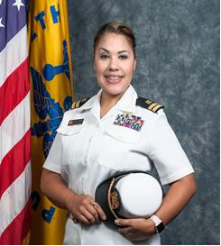

Hello Fellow Dental Hygiene Officers,

This year USPHS Scientific & Training Symposium in Dallas, TX was awesome. I was so glad to be able to personally meet familiar and new fellow dental hygienist during the breakout category session day. We were able to present our DH Award Winners for the Candace M. Jones Awards & Jr. Dental Hygienist of the Year Award (CDR Stacy Harper & LT Latasha Turner) with certificates, which was followed by award plaques they received shortly after the symposium.

Thank you all for taking the time to be a part of our DHPAG and as always I welcome any of your suggestions or ideas 😊.

**2018 DHPAG EXECUTIVE COMMITTEE**

|  |  |  |  |
| --- | --- | --- | --- |
| Chair | LCDR Ruth Williams | 305-816-1502 | ruth.williams@fda.hhs.gov |
| Chair Elect | CDR Kari Pinsonneault | 816-426-6472 | kari.pinsonneault@cms.hhs.gov |
| Secretary | LCDR Tiffany Smith | 520-464-3088 | tiffany.h.smith@ice.dhs.gov |

**Operations**

|  |  |  |  |
| --- | --- | --- | --- |
| Communications Chair | CDR Kari Pinsonneault | 816-426-6472 | kari.pinsonneault@cms.hhs.gov |
| Co-Chair | LCDR Marie-Elena Puleo (Lana) | 845-220-2122 x1101 | marie-elena.puleo@fda.hhs.gov |

|  |  |  |  |
| --- | --- | --- | --- |
| Awards Chair | LCDR Tammy Thomason | 304-626-2500  x1151 | tthomason@bop.gov |

|  |  |  |  |
| --- | --- | --- | --- |
| Stakeholder & Community Engagement Co-Chair | LCDR Nicolette Bennett | 301-443-3562 | nbennett@hrsa.gov |
| Co-Chair | LT Latasha Miller | 240-453-6006 | latasha.miller@hhs.gov |

**Officer Support**

|  |  |  |  |
| --- | --- | --- | --- |
| Recruitment Chair  (Ad Hoc) | LCDR Torrey Darkenwald | 406-477-4429 | torrey.darkenwald@ihs.gov |

|  |  |  |  |
| --- | --- | --- | --- |
| Training, Education & Mentorship Chair | LCDR Paula M. Arango | 609-723-1100  x6783 | parango@bop.gov |
| Co-Chair | LCDR Andrew Felix | 619-661-4072 | andrew.felix@ice.dhs.gov |

|  |  |  |  |
| --- | --- | --- | --- |
| Technical Readiness Chair | LCDR Torrey Darkenwald | 406-477-4429 | torrey.darkenwald@ihs.gov |

|  |  |  |  |
| --- | --- | --- | --- |
| Data & Evaluation Chair | LCDR Charles Brucklier | 301-443-0210 | cbrucklier@hrsa.gov |

**Management**

|  |  |  |  |
| --- | --- | --- | --- |
| Policy Chair | LCDR Emily Warnstadt | 509-865-1708 | emily.warnstadt@ihs.gov |
| Administrative Chair | LCDR Diane Weidley | 301-443-8106 | dweidley@hrsa.gov |

**Service Access Team (SAT) Response to Hurricane Irma in Puerto Rico**

**LCDR Paula M. Arango**

In late September 2017, while Hurricane Maria was going through Puerto Rico, the next rotating Service Access Team (SAT) was deploying to the Hurricane Irma response mission. The team included CDR Karina D. Aguilar, SAT 4; CDR Amy Chanlongbutra and myself, LCDR Paula M. Arango from SAT 1. Soon after LCDR Vesnier Lugo, SAT 2 and LCDR Fahad Alsayyid, SAT 5 joined the team. Our mission was to provide case management services to severely ill patients from the Virgin Islands who were transported to Puerto Rico in the midst of Hurricane Irma and now were again extremely impacted by Maria.

The Service Access Teams were created as part of the National Response Framework’s Emergency Support Function (ESF-8). Each SAT is a Tier 2 response team—meaning that they can deploy within 36 hours of activation. The mission of the SAT is to provide resources as well as assistance to local health authorities throughout the country and overseas. The primary functions of the SAT are Coordination of Evacuee Return, Medical Case Management, Coordination of Evacuee Travel, Coordination of Human Services, and Data Collection using the Joint Patient Assessment Tracking System (JPATS).

Each member of our team was assigned a specific role, aside from case management, to accomplish this critical mission—in addition to Team Lead and Deputy Team Lead, our team aligned positions with the Incident Command System (ICS) to provide standardization, organization, and clear lines of communication. During this deployment, there was a critical lack of connectivity and basic needs, therefore the Safety officer was important to ensure the team’s safety and location at all times. Among many duties, the Planning/Logs provided assistance with coordinating needed transportation, communications, supplies, and equipment for the mission. Given that this deployment was personal for some, the team decided to include a Morale, Welfare and Recreation (MWR) position to help us identify triggers that might compromise our disposition and to maintain our mental health.

As the prior SAT rotated out our team continued with the mission, approximately 118 patients and their non-medical assistants from the Virgin Islands needed case management and reunification assistance with their families back home. For the most part, the patients were housed in the San Juan metropolitan area hospitals and medical centers. Our team quickly learned that although Spanish was not needed to speak with the population we were serving, it was vital in order to communicate with hospital personnel. Our SAT visited the patients and their non-medical assistants at these different locations and worked alongside their social workers to contact their family members in the Virgin Islands to give them an update on their case. When patients were ready to be discharged from the hospital or facility, we assisted as needed. Sometimes we needed to secure medication; other times a wheelchair or crutches; most patients needed help with transportation. In addition, we assisted with preparing travel requests, accommodations, and assisted with airport logistics to ensure safety as they returned to reunite with their families.

As a team and as USPHS Officers, we agreed that we fulfilled our mission and felt a sense of accomplishment with every patient we were able to help with their healthcare and family reunification. Despite the lack of water, electricity, and food the Puerto Rican people we met were strong and determined to overcome their current situation.

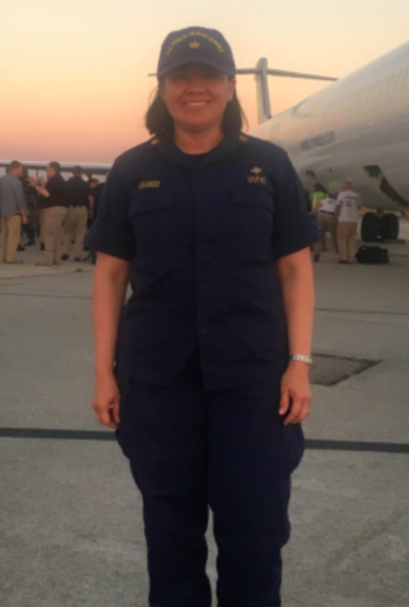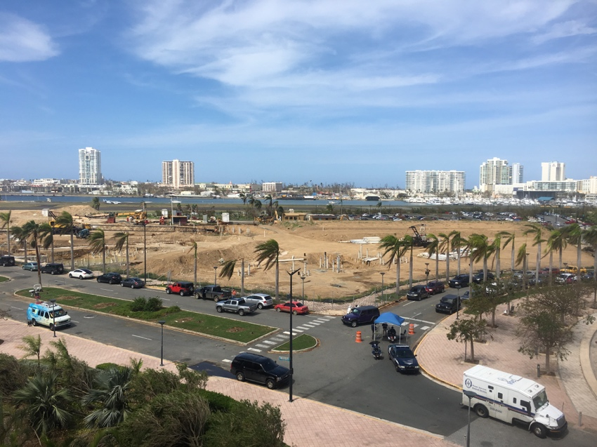

*Outside Conventional Center in San Juan, Puerto Rico*

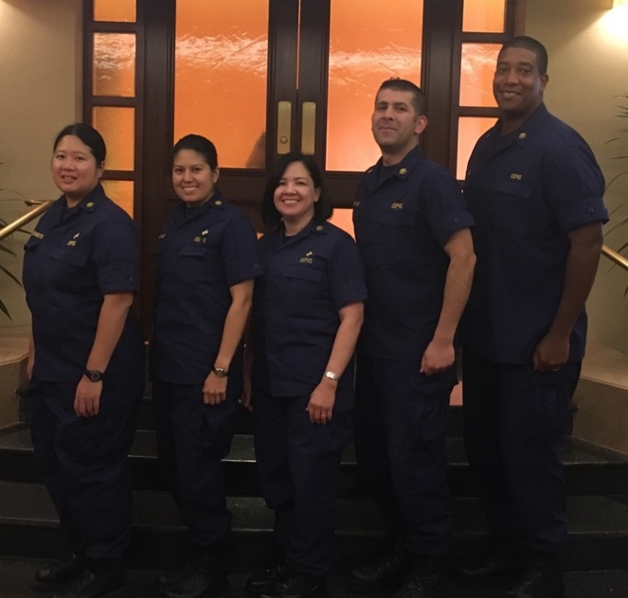*LCDR Paula M. Arango - Military Base Airport in Puerto Rico*

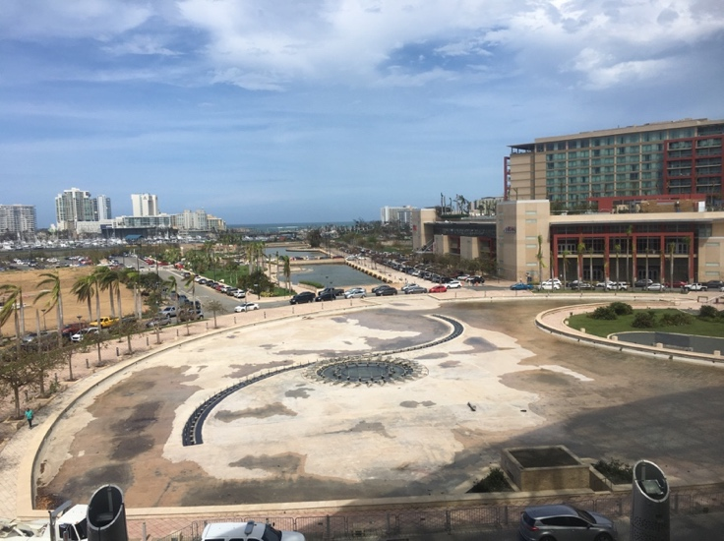

*Outside Conventional Center in San Juan, Puerto Rico Service Access Team (SAT) CDR Chanlongbutra, CDR Aguilar,*

*LCDR Arango, LCDR Lugo and LCDR Alsayyid in Puerto Rico*

**Committee Corner**

**COMMUNICATIONS COMMITTEE**

***WANTED***: Articles for newsletters

***A day in the life of a RDH***

***Alternative Career Paths***

***Upcoming Conferences***

***Volunteer Opportunities and Engagement***

***Community Events***

***Tips for Successful PCS***

***Deployment Experience***

***Kudos for promotions and awards***

What do you want to see in the Newsletter?

**Newsletter Submission Deadlines:**

Issue III Oct 26th

**AWARDS COMMITTEE**

**Candace M Jones Award Winner: CDR Stacy Harper**

**Junior Dental Hygienist of the Year Award Winner: LT Latasha Turner**



**STAKEHOLDER & COMMUNITY ENGAGEMENT COMMITTEE**

**POLICY COMMITTEE**

**RECRUITMENT COMMITTEE**

Interested in Serving on the DHPAG?

Collaboration, Participation and Engagement

Submit name to:

LCDR Torrey Darkenwald

[Torrey.darkenwald@ihs.gov](mailto:Torrey.darkenwald@ihs.gov)

**TRAINING, EDUCATION & MENTORSHIP COMMITTEE**

Thank you for attending the Panel Discussion, **“Sending the Elevator Down. Words of Wisdom from the Top Floor.”** Please submit any feedback or suggestions you have for the Panel Discussion using this survey: <https://www.surveymonkey.com/r/C5D2MQ8>.

Choose from more than 150 FREE dental continuing education courses at

<https://www.dentalcare.com/en-us/professional-education/ce-courses>

**TECHNICAL READINESS COMMITTEE**

Deployment related awards - RedDOG is working on this issue

**DATA & EVALUATION COMMITTEE**

Survey will be coming out to compile information about board requirements

of clinical hours to maintain licensure

**ADMINISTRATION COMMITTEE**

**DHPAG Meeting Dates: *October 9th & December 11th***

**Voting Member (Chair Positions) Vacancies and Voting Member submission deadlines are the following:**

**1. Communications Chair:** July 31st – September 8th

**2. Recruitment Chair (Non-Voting Position):** July 31st – September 8th

**3. Technical Readiness Chair:** July 31st – September 8th

**4. DH PAG Chair-Elect:** October 16th –November 3rd

**5. DH PAG Executive Secretary (Non-Voting Position):** October 16th – November 3rd

**\*Non-voting member openings for all committees is always open, please email the Chair of the specific committee and be an active participant.**

**Mark Your Calendar**

**MARK YOUR CALENDARS**



**The Future of Health Care is Now, 27 Nov – 30 Nov 2018**

**Gaylord Conference Center, National Harbor, MD**

**“127th Meeting**”

[http://www.amsusmeetings.org](http://www.amsusmeetings.org/)



FREE: <https://www.dentalcare.com/en-us>

FREE: <http://vivalearning.com/>



Certified Correctional Health Professional (CCHP): <http://www.ncchc.org/cchp>

Dental Hygiene Professional Advisory Group (DHPAG) Coin Order Form

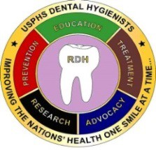 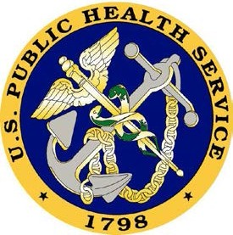

**Price: $12**

Name:

Address (for shipment):

City/State/Zip Code:

E-mail:

Phone:

Quantity:

Total Enclosed: (including S&H) (*Please make the check payable to:* ***Commissioned Officers Foundation****)*

Send your check and this form to: LCDR Angelica Chica

**Shipping and Handling:**

Less than 10 coins= $5.00

10 or more coins= $7.00

U.S. Food and Drug Administration 15100 NW 67th Ave, Suite 400 Miami Lakes, FL 33014

***QUESTIONS: Contact LCDR Chica at 305-816-1450 or [angelica.chica@fda.hhs.gov](mailto:angelica.chica@fda.hhs.gov)***

[angelica.chica@fda.hhs.gov](mailto:Angelica.chica@fda.hhs.gov)