**Multidisciplinary in Approach, Connected by Service, Advancing Public Health #WeAreCoprsSTRONG**

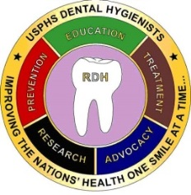 ***The Fulcrum***

Note From DHPAG Chair

LCDR Angelica Chica, RDH, BASDH, MPA 2017 Issue II

**Note from Chair**

**DHPAG Executive Committee Chart**

**DHPAG Executive Committees**

**Article: LT Tiffany Smith**

**Article:** **Values Assessments.**

**CAPT Candace Y Hander**

**Article: Sharp as a Sickle**

**LT Latasha Turner**

**Committee Corner**

**Junior Dental Hygienist of the Year Award Winner**

**Candace Jones Award Winner**

**Article: Leadership**

**CAPT Candace Y Hander**

**Open active duty dates**

**Newsletter Deadlines**

**DHPAG Coin Purchase**

**Co-Editors:**

**LCDR Tammy Thomason**

**LCDR Kelli Shaffer**

**LCDR Marie-Elena C. Puleo**

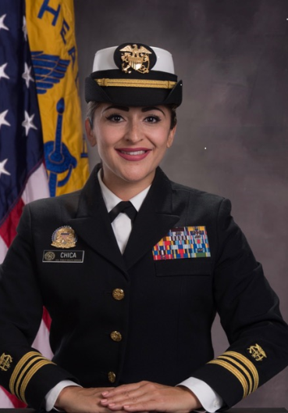

“So much to do and so little time”.  This is a phrase I have often heard and verbalized myself a time or two (wink, wink). I wanted to talk a little bit about work life balance in this issue of the Fulcrum.  At the time that I am writing this message we have been 3-4 months into 2017 and boy did we hit the ground running within our PAC/PAG.  As members of a uniformed service and USPHS officers there is always more expected from us.  No offense to anyone that has ever worked as a General Service employee (or who will work as one post UPSHS retirement) but the truth is that by wearing the uniform we have signed on to defend the constitution of the United States; to be physically and mentally ready to deploy when asked/needed; and to be essentially available when needed, 24/7.  We all have an agency that has hired us to facilitate their mission AND we are all Active Duty members of the USPHS; we wear dual career hats every day.  When we get to “clock out” for the duty day we have other hats we wear: mother/father; sister/brother, daughter/son, aunt/uncle; humanitarian, etc. This is life; full of hustle and bustle; but in that noise of life we need to all learn how to balance both worlds of work and life.  The World Health Organization (WHO) defines health as, “a state of complete physical, mental, and social well-being and not merely the absence of disease or infirmity.” We need to be healthy to accomplish our life roles; here are some tips on how to do just that:

•         Turn off your phone or disconnect from work e-mails/calls when you are home---I understand that some of us have jobs that require us to be on call, I had one of those jobs a couple of years ago.  What I have learned is that not every message/e-mail is an emergency, tomorrow is another day and that message can be addressed then.  If delaying a responding to an e-mail/or message is not going to hurt anyone then delay.

•         Get plenty of rest---Rest helps our cells rejuvenate.  The list of benefits from getting enough sleep (recommended 6-8 hours a night) is extensively long, not only will you have more energy and be able to concentrate better/improve your memory but you will also be able to live longer! (<http://www.webmd.com/sleep-disorders/features/9-reasons-to-sleep-more#1>; <http://www.health.com/health/gallery/0,,20459221,00.html>)

•         Know your limits---It is so important to know how much you can handle, be it with work assignments or at home.  Do not over extend yourself and ask for assistance when it is needed (this is both at home and at work)

•         Take some YOU time---It is important to always take time for yourself; a moment of meditation or quietness, maybe just reading a journal or book.  If we do not take care of ourselves then we will not be able to take care of others needs be it at work or home.

As this year continues to unfold and more agency work, UPSHS additional duties, and home demands continue to build keep the WHOs definition of health and these tips in mind to help center yourself and find that much needed balance.  Tomorrow, if granted to us, is another day to tackle our list of “To Do’s.”  I appreciate everyone’s work on our PAG especially the flexibility as we are transitioning through new changes and demands.  I cannot say THANK YOU enough.  Do you have any tips for work life balance?  Our DHPAG family would love to hear what you do to stay balanced.  Send your tips to the Communications Subcommittee so that we can feature them in the next issue of the Fulcrum.



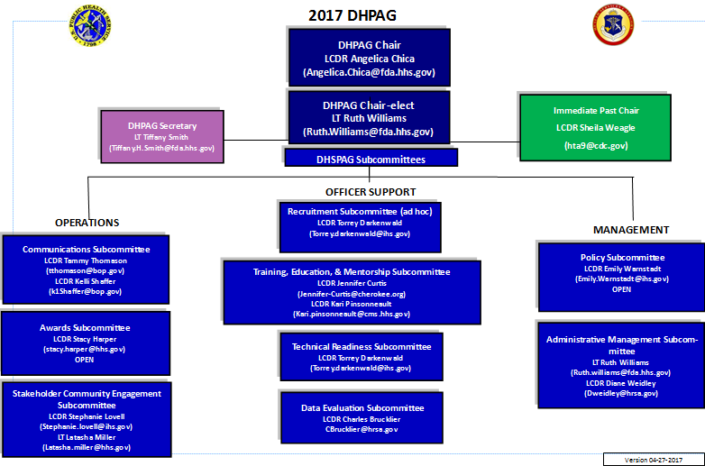

**2017 DHPAG EXECUTIVE COMMITTEE**

|  |  |  |  |
| --- | --- | --- | --- |
| **Chair** | **LCDR Angelica Chica** | 305-816-1450 | Angelica.Chica@fda.hhs.gov |
| **Chair Elect** | **LT Ruth Williams** | 305-816-1502 | Ruth.Williams@fda.hhs.gov |
| **Secretary** | **LT Tiffany Smith** | 520-464-3088 | Tiffany.H.Smith@ice.dhs.gov |

**OPERATIONS**

**Communications:**

|  |  |  |  |
| --- | --- | --- | --- |
| **Chair** | **LCDR Tammy Thomason** | 304-626-2500  Ext. 1151 | tthomason@bop.gov |
| **Co-Chair** | **LCDR Kelli Shaffer** | 805-735-2771  Ext. 3376 | K1Shaffer@bop.gov |
| **Committee Member** | **LCDR Marie-Elena C. Puleo** | 845-220-2122 | marie-elena.puleo@fda.hhs.gov |

**Awards:**

|  |  |  |  |
| --- | --- | --- | --- |
| **Chair** | **LCDR Stacy Harper** | 216-767-3490 | Stacy.harper@hhs.gov |
| **Committee Member** | **Open** |  |  |

**Stakeholder & Community Engagement**

|  |  |  |  |
| --- | --- | --- | --- |
| **Chair** | **LCDR Stephanie Lovell** | 405-247-7961 | Stephanie.lovell@ihs.gov |
| **Co-Chair** | **LT Latasha Miller** | 240-453-6006 | Latasha.miller@hhs.gov |

**Officer Support**

**Recruitment:**

|  |  |  |  |
| --- | --- | --- | --- |
| **Chair** | **LCDR Torrey Darkenwald** | 406-477-4429 | Torrey.darkenwald@ihs.gov |
| **Committee Member** | **Open** |  |  |

**Training, Education & Mentorship:**

|  |  |  |  |
| --- | --- | --- | --- |
| **Chair** | **LCDR Jennifer Curtis** | 918-256-4800 | jennifercurtis@cherokee.org |
| **Co-Chair** | **LCDR Kari Pinsonneault** | 218-983-6285 | Kari.pinsonnault@ihs.gov |

**Technical Readiness:**

|  |  |  |  |
| --- | --- | --- | --- |
| **Chair** | **LCDR Torrey Darkenwald** | 406-477-4429 | Torrey.darkenwald@ihs.gov |
| **Committee Member** | **Open** |  |  |

**Data & Evaluation:**

|  |  |  |  |
| --- | --- | --- | --- |
| **Chair** | **LCDR Charles Brucklier** | 301-443-0210 | cbrucklier@hrsa.gov |
| **Committee Member** | **Open** |  |  |

**Management**

**Policy:**

|  |  |  |  |
| --- | --- | --- | --- |
| **Chair** | **LCDR Emily Warnstadt** | 509-865-1708 | Emily.Warnstadt@ihs.gov |
| **Co-Chair** | **LCDR Tammy Thomason** | 304-626-2500 X1151 | tthomason@bop.gov |

**Administrative:**

|  |  |  |  |
| --- | --- | --- | --- |
| **Chair** | **LT Ruth Williams** | 305-816-1502 | Ruth.Williams@fda.hhs.gov |
| **Co-Chair** | **LCDR Diane Weidley** | 301-443-8106 | Dweidley@hrsa.gov |

2016 AMSUS Annual Meeting (125 Anniversary)

Submitted by: LT Tiffany H. Smith, RDH, BSDH, MSEDM

Executive Secretary 2017, Dental Hygiene Professional Advisory Group

I would like to start by saying thank you in advance for opportunity and privilege to be the Dental Hygiene Professional Advisory Group (DHPAG) Executive Secretary for 2017. Last year, LCDR Suzanne Redmon did an excellent job as secretary and I appreciate her guidance and time she took with me to pass the baton for a smooth transition in my new role as a secretary.

Before sharing my first-time experience of attending the 2016 AMSUS (Association of Military Surgeons of the United States) Annual Meeting, I would like to briefly tell you a little bit about myself. I graduated from Northern Arizona University (NAU) in 2008 with a Bachelor of Science in Dental Hygiene (BSDH). Out of all the dental hygiene programs in Arizona, I felt that NAU had the strongest emphasis in public health. The program consisted of rotations to the Hopi, Winslow, and Yavapai dental clinics to treat the underserved populations of the Native American Indians. Soon after receiving my degree, I was commissioned to serve as a USPHS officer with the Federal Bureau of Prisons (FBOP) in Long Beach, CA at FCI Terminal Island. In mid-April 2016, I transferred agencies while continuing to work in a clinical setting for the U.S. Department of Homeland Security (DHS), U.S. Immigration and Customs Enforcement (ICE), Enforcement and Removal Operations (ERO), ICE Health Services Corps (IHSC) at the Eloy Detention Center in Eloy, AZ. In March 2017, I received a Master of Science in Emergency & Disaster Management (MSEDM), with a Concentration in Logistics from Trident International University. With this degree, I will continue to seek deployment opportunities for enrichment of personal growth.

As previously stated, I attended the 2016 AMSUS Annual Meeting, which celebrated 125 years of professional healthcare collaboration throughout its Federal agencies, military, civilian, and international partners. I had the great privilege to serve on the PHS AMSUS Planning Committee as the Dental Vice Chair with CDR Vicky Ottmers, DDS, who was the 2016 Dental Professional Advisory Committee (DePAC) Chair. This experience was quite educational and provided an amazing ability to network with my fellow officers of all professional disciplines. In fact, AMSUS’s 2016 theme “Raising the Bar” held true on a multitude of levels. As for dental in particular, it appears that AMSUS has come a long way for both dentists and dental hygienists in the past two years and improving our numbers of support for future annual meetings would likely prove to be beneficial in a number of ways. Most notably, this is the second year in row dentists and dental hygienists have been able to receive continuing education (CE) hours. In 2015, 20.5 CE hours was attainable, followed by 19.25 CE hours in 2016. All AMSUS conference abstracts were reviewed for dental CE by CAPT Lynn Van Pelt, DMD (also Oral Health Session Coordinator) and CDR Ottmers. Secondly, in 2016 the dental team had their first multi-disciplinary, collaborative “Oral Health Track Session” with the targeting audience being all primary care professionals. On a side note, CDR Ottmers and myself provided purple pens with the date and time of the Oral Health Track Session as a marketing tool for the session. Our intention was to promote collaboration while networking with all service branches and professional disciplines.

In addition, the courses were quite extensive, covering epidemiology, dental emergencies in overseas operations, obstructive sleep apnea, combat zone maxillofacial care, and tobacco signs/symptoms/treatment (oral pathology), including HPV and vaping (electronic cigarettes). During the oral track session, Henry Schein Dental sponsored a 30-minute networking break with refreshments. Furthermore, the array of presenters included USPHS, Army, Air Force, Navy, and an International speaker from the French Armed Forces. Finally, a highlight of the session was when each presenter received a Certificate of Appreciation and the AMSUS 125 anniversary coin from RADM Nicholas S. Makrides, DMD, MA, MPH, who serves as the Chief Dental Officer of the FBOP. As well as, I volunteered as the Aide-de-Camp for RADM Makrides.

This year, I will be taking on a stronger role in the PHS AMSUS Planning Committee as the 2017 Dental Chair. I am privileged to have the continued opportunity to serve alongside CDR Ottmers who will be the 2017 Dental Vice Chair.

The 2017 AMSUS Annual Meeting will be held at the Gaylord National Resort & Convention Center, in National Harbor, MD. This year the theme will be “Force Health Protection: From Battlefront to Homefront”. The annual meeting follows the week after the Thanksgiving holiday on November 28 – December 1, 2017. For more information, please visit the AMSUS link at: <http://www.amsus.org/>.

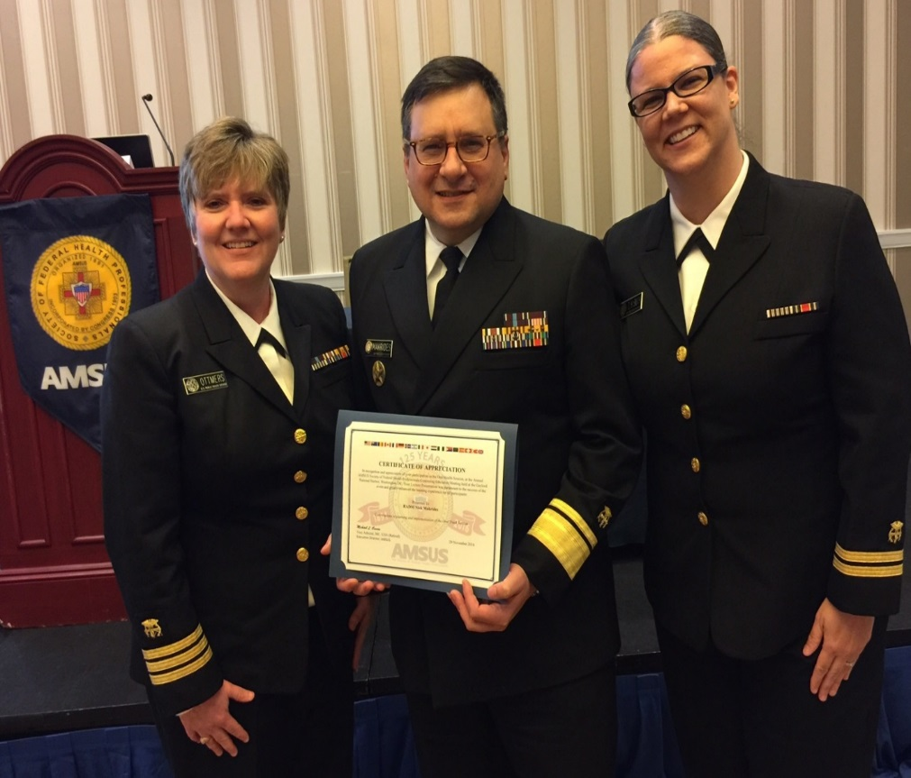

*CDR Vicky Ottmers, DDS (left) and LT Tiffany H. Smith, RDH (right) presented RADM Nick S. Makrides, DMD (center)* the AMSUS Certificate of Appreciation for his outstanding contributions as Master of Ceremonies.

*Not pictured is CAPT Lynn Van Pelt, DMD.*

**Honoring Values in the Workplace**

CAPT Candace Y Hander

Have you ever hit a point where you started to feel out of place somehow at your job? Things happen and it just feels like sandpaper rubbing up against you? Earlier in my career, I used to say, “When I start feeling like this, it is time to look for a new job.” I might have been able to point to specific things that were going on, but I could not explain the underlying cause of why I felt that way back then. What was it that began to make me feel this type of discomfort?

What I know now, is that when the values of the organization (or your supervisor) feel incongruent with your values, it can create a feeling of disconnectedness. You may feel like nothing you say or do matters, or that you are put in a position to do things in a way that does not feel right somehow. This could manifest in a variety of different ways, and different people experience this differently, but most would agree that their general sense of satisfaction, comfort and happiness in their job has faded, and their discomfort has risen. Often at the root of this sense of disconnectedness are values.

For example, if your supervisor’s value is to have good numbers on a spreadsheet about the volume of patients seen in your facility, and your values are to provide a good and thorough service for everyone that you treat; this could lead to a values mismatch.

If a values mismatch occurs, what can you do about it to create a feeling of cohesion for yourself and your work team?

Do you know what the values of your organization are? The mission and vision statements are a good place to look for these. Do the practices in your organization seem to support these? You could hold a team meeting and brainstorm what your values are as a group.

When our beliefs of behaviors are out of alignment with what is important to us – our values, we lack authenticity.

Below is a link to a free online assessment that will help you become more aware of your own values and how these values influence your decisions, actions, and reactions.

<https://www.valuescentre.com/our-products/products-individuals/personal-values-assessment-pva>

Working together, defining what your group values are, and then sharing your personal values can create better meaning for all and give you a way to bring everyone together around a common set of values.

**“Sharp as a Sickle”**

**LT Latasha Turner, RDH, BS**

**As dental hygienists, we know the significance of maintaining instrument sharpness. We understand that a sharpened instrument eliminates unnecessary discomfort for patients and providers, eliminates burnishing of calculus and should be a continuing practice. We also know that we should not allow our instruments to get too dull; otherwise, we will spend more time later trying to get that sharp cutting edge back. Furthermore, we know if we sharpen our instruments on an ongoing basis, we are always prepared to conquer the calculus! The same is true for our personal and professional instruments (skills).**

**One way that we can stay sharp (especially those of us who are not in full-time clinical positions) is by volunteering.**

**Mission of Mercy projects offer dental hygienists an opportunity to keep our skills sharp by providing free dental care to low-income, underinsured, underserved populations or those who may not otherwise have access to oral care. For example, according to the Virginia Health Care Foundation, “an estimated 47% (3.8 million Virginians) do not carry dental insurance and many of the 81 localities only offer a dental provider on a part-time basis (2017). MoM projects are typically 2-day clinics situated in rural, underserved communities where oral health needs are not adequately met. Most missions are fully operational and offer varied services such as: hygiene, preventive, operative, anterior root canals, extractions and some even offer a limited amount of removable prosthodontic appliances (full dentures). Commonly, patients are seen on a first-come, first-served basis. Close to 1,000 individuals could be treated on any given day at a MoM project. In addition, we (hygienists) can be the relief to hundreds of patient’s discomfort, potential pain, embarrassment and help them smile confidently again.**

**Other than direct patient care, MoM project hygienists may be used in other areas to include radiology, anaesthesia, sterilization, patient education or counselling, triage, assisting, or records/administration. Talk about staying sharp! MoM projects offer the hygienist wonderful opportunities with an array of experiences, a sense of service while carrying out a completely gratifying mission. Lastly, most states will grant Continuing Education credit for volunteering (number of credits dependent upon the state).**

**Each state that offers MoM projects has a corresponding website and some can be found on social media (i.e. Facebook). To find out more information or find a MoM project in your area/state, check with your state or local Dental (or Dental Hygienists’) Association. You may also enter “Mission of Mercy [your state]” into your favorite search engine.**

**Happy Sharpening!**

**Virginia Health Care Foundation. (2017). Dental statistics and research. Retrieved from**

[**http://www.vhcf.org/data/statistics-and-research-on-dental-access/**](http://www.vhcf.org/data/statistics-and-research-on-dental-access/)

**Committee Corner**

**COMMUNICATIONS**

***WANTED***: Articles for newsletter

We will post ***Community Events***

We would like to know your RDH experiences; ***A day in the life of a RDH in (agency name)***

We will post ***Upcoming Conferences***

What do you want to see in the Newsletter?

**Awards**

Co-Chair – Open

If interested in this position contact LCDR Angelica Chica

[Angelica.Chica@fda.hhs.gov](mailto:Angelica.Chica@fda.hhs.gov)

**Stakeholder & Community Engagement**

Nothing to report at this time

**Recruitment**

Co-Chair – Open

If interested in this position contact LCDR Angelica Chica

[Angelica.Chica@fda.hhs.gov](mailto:Angelica.Chica@fda.hhs.gov)

**Training, Education & Mentorship**

The DHPAG Training, Education, Mentorship subcommittee would like to place a save the date in the newsletter for the following:

**Title: Serving outside the RDH Clinical Role**

**When: Thursday, June 1st, 2017 from 12:00-1:00pm CST**

**Where: Conference Call/Webinar**

**Who: DHPAG Training, Education, & Mentorship Subcommittee**

**Our Honored Guest Speakers are:**

**•             LCDR Charles Brucklier, RDH Project Officer, Health Resources and Services Administration, Bureau of Primary Health Care**

**•             CAPT Candace Y Hander, ACC, Senior Health Services Manager, FDA, Center for Drug Evaluation and Research**

**•             LCDR Stacy Harper, RDH, MPH Public Health Advisor**

**Technical Readiness**

1. Seeking input on trainings that would help us as hygienists and PHS Officers be better prepared for deployment. If you have trainings that you have attended or that you are aware of that might benefit others please forward the information on to LCDR Darkenwald at torrey.darkenwald@ihs.gov.

2. Volunteers welcome! The technical readiness subcommittee is looking for those that are interested in establishing some foundational work with the HSPAC.

3. Dental Deployment Webinar:

May 18th, 2017 @ 1500hrs-1600hrs

[Join WebEx meeting](https://fda.webex.com/fda/j.php?MTID=m64b1facde8fd2e8df11ea7523c36fbaa)

Meeting number:          [744 406 120](tel:744406120)

Meeting password:       010203

   
Join by phone     
Local: [1-301-796-7777](tel:13017967777)     
toll free: [1-855-828-1770](tel:18558281770)    
Cisco Unified MeetingPlace meeting ID: [744 406 120](tel:744406120)    
Cisco Unified MeetingPlace profile number for meeting host: 45759671

Co-Chair – Open

If interested in this position contact LCDR Angelica Chica

[Angelica.Chica@fda.hhs.gov](mailto:Angelica.Chica@fda.hhs.gov)

**Data & Evaluation**

Chair– Open

Co-Chair – Open

If interested in this position contact LCDR Angelica Chica

[Angelica.Chica@fda.hhs.gov](mailto:Angelica.Chica@fda.hhs.gov)

**Policy**

SOP template is currently in review. Once the Voting members (HSO) have approved recommendation it will be released to the PAGs. The HS PAC Policy Subcommittee is also currently reviewing and modifying the 2011 HSO Resource Directory to be in place by Sept 2017.

Administration

1. To aid in soliciting new PAG voting members and oversee the voting member process for the 2018-2020 term.

2. Manage the RDH PAG Listserve and maintain an up-to-date subscriber list.

3. Annually review the PAG bylaws and SOPs.

_____________________________________________________________________________

As you can see, the goals I have set for the Administrative Management Subcommittee fall in line with the current HS PAG Bylaws. While serving as your Chair Elect for our PAG, I am also heading this subcommittee and welcome your participation.

I just want to take a brief moment to introduce and welcome my new Co-Chair, LCDR Diane Weidley, who graciously volunteered to join this committee. She currently works in Rockville, MD for Health Resources & Services Administration (HRSA).

If anyone has any ideas for soliciting new voting members or any other suggestions for this committee, please feel free to contact us!



**Junior Dental Hygienist of the Year Award**

**Winner**

**LCDR Jennifer Huff**

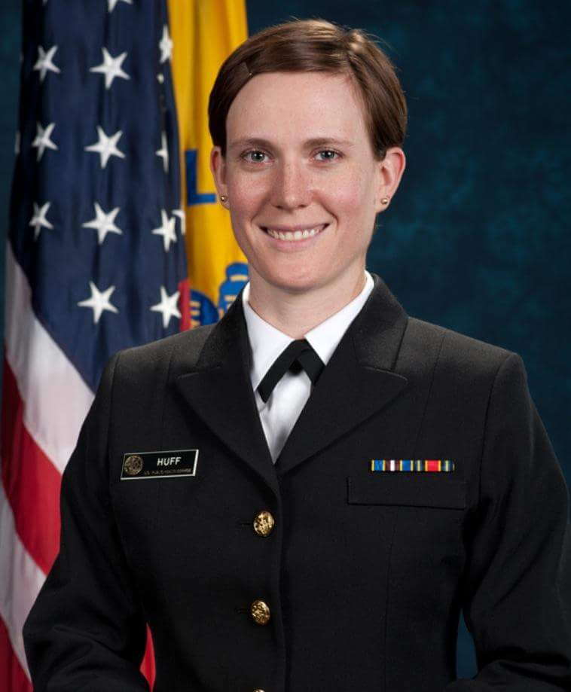

LCDR Huff started her career with the Indian Health Service (IHS) dental clinic in Bethel, Alaska at the Yukon-Kuskokwim Health Corporation’s (YKHC) Dental Clinic. Bethel is an isolated hardship area and is an underserved village. The facility she worked at provided dental care for over 75,000 square miles (over 50 villages) and serves 25,000 Alaskan Natives. She was one of three dental hygienists that traveled by plane and boat to provide both preventive services and education for the area serviced by YKHC. LCDR Huff currently serves as a staff dental hygienist for the Kenaitze Tribe in Denai, Alaska. She completed her Bachelor of Science in dental hygiene from Texas Women’s University in Denton, Texas in 2004.



**Candace Jones Award Winner**

**CDR Mylene I Santulan**

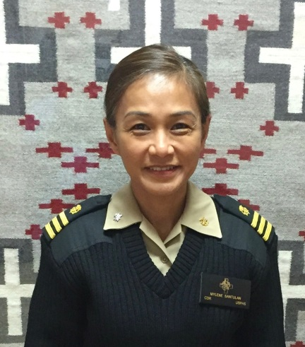CDR Mylene I. Santulan is a dental hygienist serving in the advanced community/clinical position at Tsehootsooi Medical Center Dental Department at Fort Defiance, AZ. Currently, she also serves as the department’s Interim Supervisory Dental Hygienist/Oral Health Program Manager. Her work experiences encompass 23 years as a clinician, educator, and public health advocate in private practice, military installations, and eight and a half years in the Commissioned Corps. In the past, she also served with the United States Air Force. CDR Santulan obtained her undergraduate degree from Southern Illinois University and her graduate studies—Masters in Health Science focusing in International Health from Trident University International. At present, she is pursuing a certification degree in project management from Villanova University. She is originally from the Philippines. She loves food, music, dogs, travel, and seeks for opportunities to serve in a global capacity.

**Mark Your Calendar**

The International HOSA conference will this year in Orlando Florida from June 21-24.  They are in need of competition judges for medical techniques and tabletops (dental assisting is one of them) and to teach Rx for Change (USPHS initiative for Tobacco Cessation). [www.hosa.org](http://www.hosa.org)

NNOHA Annual Conference, San Diego, CA - <http://www.nnoha.org/event/2017-nnoha-annual-conference/>



**Dental Deployment Webinar: May 18th, 2017 @ 1500hrs-1600hrs**

**Serving outside the RDH Clinical Role** ***When*:** June 1 ***Time*:** 12:00 – 1:00

***Sponsored by:*** DHPAG Training, Education, and Mentorship Subcommittee. (See next page)



FREE: <https://www.dentalcare.com/en-us>

FREE: <http://vivalearning.com/>



Certified Correctional Health Professional (CCHP) <http://www.ncchc.org/cchp>

Certified Public Health: <https://www.nbphe.org/>

**Dental Deployment Webinar:**

**When:** May 18th, 2017 @ 1500hrs-1600hrs

**Where:** Conference call/webinar

**Meeting access information:**

[Join WebEx meeting](https://fda.webex.com/fda/j.php?MTID=m64b1facde8fd2e8df11ea7523c36fbaa)

Meeting number:          [744 406 120](tel:744406120)

Meeting password:       010203

Join by phone     
Local: [1-301-796-7777](tel:13017967777)     
toll free: [1-855-828-1770](tel:18558281770)    
Cisco Unified MeetingPlace meeting ID: [744 406 120](tel:744406120)    
Cisco Unified MeetingPlace profile number for meeting host: 45759671

**Serving outside the RDH Clinical Role**

**When:** Thursday, June 1st, 2017 from 12:00-1:00pm CST

**Where:** Conference Call/Webinar

**Who:** DHPAG Training Education & Mentorship Subcommittee will be hosting a conference call/webinar on Serving outside the RDH Clinical Role. Our honored Guest Speakers are:

* CAPT Candace Y Hander, ACC, Senior Health Services Manager, FDA, Center for Drug Evaluation and Research
* LCDR Charles Brucklier, RDH Project Officer, Health Resources and Services Administration, Bureau of Primary Health Care
* LCDR Stacy Harper, RDH, MPH Public Health Advisor

**Meeting Access Information:**

1. Please call the following number:

WebEx: 1-877-267-1577

2. Follow the instructions you hear on the phone.

Your WebEx Meeting Number: 997 171 054

To join from a Cisco VoIP enabled CMS Region or from CMS Central Office

1. Dial ext. 63100

Enter Meeting Number: Use Meeting WebEx Number provided above.

To join this meeting online

1. Go to <https://meetings.cms.gov/orion/joinmeeting.do?MTID=9d0f20e47d063552d2c7d4dfa8fbef5f>

2. If requested, enter your name and email address.

3. If a password is required, enter the meeting password.

4. Click “Join”.

5. Follow the instructions that appear on your screen.

|  |  |  |
| --- | --- | --- |
| Respectfully,  LCDR Jennifer Curtis Chair  LCDR Kari Pinsonneault Co-chair | | |
| DHPAG Training, Education, Mentorship Subcommittee  Health Services Category  United States Public Health Service | | |
| *Connect with us:* | | |
| [Description: Description: Description: cid:image003.png@01D1DC24.E04D9810](http://www.usphs.gov/) |  | ***Multidisciplinary in Approach,*** ***Connected by Service,*** ***Advancing Public Health***  ***#WeAreCorpsSTRONG*** |

**If your actions inspire others to dream more, learn more, do more and become more, you are a leader.**

CAPT Candace Y Hander

Each of you is a wealth of information, and most of you have had interesting and exciting careers!

What have you learned along the way??? It is a great benefit for all of us in many ways, and especially to our new Hygienists.

Remember when you were new and feeling kind of lost? Lead the way and share your wisdom with your colleagues!

**Possible topics:**

* Anything dental related -infection control, JCAHO, new products etc.
* Anything USPHS related Your PHS career, recommendations to other officers, readiness topics, advancement, recommendations on obtaining a higher billet or changing agencies,
* Deployment opportunities, or did you participate in a deployment? We all want to hear about it, tell us more and pictures please!
* If you know of any Community Events, upcoming conferences, or continuing education courses, please email us to add in the upcoming Newsletter.

It takes a village and as a village member please put it on your to-do list to write at least one article per year for our newsletter. Inspire us with your insight, and share what you know!!!

**Bonus:** You will be able to add the published article in your CV, and you will receive a certificate for your published article. We all need this for promotion, so help yourself while helping our PAG!!

**Reminder:** The deadline for the September newsletter is August 17. If you are planning on submitting an article let us know by July 17.

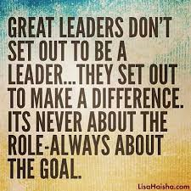

**WHAT DOES LEADERSHIP**

**MEAN TO YOU???**



Leadership means different things to different people around the world, and different things in different situations. The word "leadership" can bring to mind a variety of images. What is your definition of leadership?

**Guidelines:** Times New Roman 12 font. Length can be a little as a paragraph or as long as one page. Pictures may be included.

**BONUS:** Submit your article by August 1 to be included in our next newsletter and receive a participation certificate.

-------------------------------------------------------------------------------------------------------------------------------

**PROMOTING USPHS**

**WHAT WOULD YOU SAY TO A POTENTIAL OFFICER?**

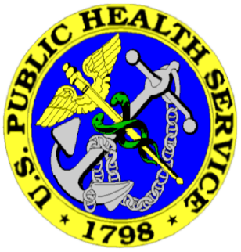

**Guidelines:** Times New Roman 12 font. Length can be a little as a paragraph or as long as one page. Pictures may be included.

**BONUS:** Submit your article by August 1 to be included in our next newsletter and receive a participation certificate

**OPEN ACTIVE DUTY APPLICATION PROCESS**

**FOR POTENTIAL COMMISSIONED CORPS APPLICANTS**

Environmental Health from May 15, 2017 to June 15, 2017

Therapist, Physician Assistant, Psychiatric Nurse Practitioner: continuous openings beginning on June 1, 2017

Nurse from June 1, 2017 to June 30, 2017. Only direct patient care clinical positions in areas of need: IHS, BOP, ICE, NIH, and FOH

Dietitian from June 5, 2017 to June 16, 2017

Engineer from July 3, 2017 to July 31, 2017

Pharmacy from July 3, 2017 to July 31, 2017

Health Services: Medical Technology, Clinical Psychology, Licensed Clinical Social Worker from August 14, 2017 to September 8, 2017

Scientist from September 1, 2017 to September 29, 2017

Veterinarian from September 1, 2017 to September 29, 2017

Newsletter

Deadlines

If you would like to publish an article please submit on or before the dates listed below.

Aug 17th for Sept newsletter

Oct 16th for Nov newsletter

(Please add pictures with each article)

**Send articles:**

[tthomason@bop.gov](mailto:tthomason@bop.gov)

[K1shaffer@bop.gov](mailto:K1shaffer@bop.gov)

[marie-elena.puleo@fda.hhs.gov](mailto:marie-elena.puleo@fda.hhs.gov)

**HOW MANY WILL TAKE THE CHALLENGE AND BUY A COIN THIS MONTH?**

***Dental Hygiene***

***Professional Advisory Group Coin***

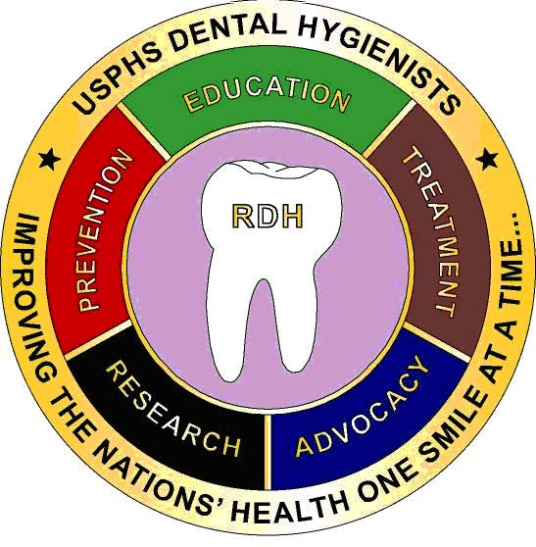

**ORDER TODAY**

LCDR Angelica Chica

**305-816-1450**

**Angelica.chica@fda.hhs.gov**