POLICY & PROCEDURE
(insert name of Hospital/Clinic)
Pharmacy Based Immunization Services
Contents
ASSOCIATED POLICIES 2
Needlestick Safety & Prevention 2
SUBJECT 2
PURPOSE 2
GOALS 2
POLICY 2
PHARMACY IMMUNIZATION PROVIDERS 3
PROCEDURES 3
Patient Eligibility Criteria: 3
Referrals: 3
Immunization Visit: 3
Patient Monitoring: 4
Prescriptive Authority/Standing Orders: 5
Authorized Adjunct Medication: 5
Scheduling of Vaccine Administration: 5
Contraindications/Precautions: 5
Follow-Up: 6
Adverse Drug Reactions (ADR’s) & Errors: 7
EVALUATION AND OUTCOMES (See Appendix G) 7
REFERENCES 7
ATTACHED APPENDICES 7
PROTOCOL/PROCEDURES APPROVAL – March 8, 2019 8
Appendix A: Screening questions for all vaccines: 9
Appendix B: Pharmacy Immunization Note (example) 10
Appendix C: Interpretation of Titer results 12
Appendix D: Medical Management of Vaccine Reactions Protocol 13
Appendix E: Example Immunization Table 18
Appendix F: Example of a Disease State Guidance Document 21
Appendix G: Outcomes Data Templates (example) 22
Appendix H: Skills Assessment 23

ASSOCIATED POLICIES

Needlestick Safety & Prevention
Medication Administration
Adverse Drug Reaction

SUBJECT

Justifications for maintaining an Immunization Clinic in the pharmacy include:
- Pharmacists are accessible healthcare providers and patients may see pharmacists more often than their primary care provider (i.e. while picking up medication refills).
- Pharmacists often encounter more than just the patient, such as siblings, parents, or guardians who may need a vaccine(s).
- Inpatient care focuses on acute illnesses and may omit health care maintenance items, such as vaccines. This represents a missed opportunity.

The Pharmacy Based Immunization Service provides vaccinations to patients who are delinquent or missing vaccine(s), or at high risk for over 20 vaccine preventable diseases.

PURPOSE
To support the USPHS mission.

To improve rates for catch-up adolescent and adult immunizations.

GOALS
- Identify patients who are missing or delinquent in a vaccine or series
- Make vaccines more accessible to patients
- Read, interpret, and analyze vaccines schedules to determine if a vaccine is indicated for a particular patient and/or if a patient is at high risk for a vaccine preventable disease
- Educate patients about the importance of vaccines, and the seriousness of vaccine preventable diseases
- Increase immunization rates to meet the “Healthy People 2020” goal of >90%, and IHS Director’s Health Promotion/Disease Prevention Initiative
- Reduce the spread of vaccine preventable diseases
- Reduce appointment demand during the influenza season

POLICY
Immunizing pharmacists will provide necessary vaccinations to patients who meet the eligibility criteria. Pharmacist providers will read, interpret, and analyze vaccine schedules to ensure the vaccine is appropriate for each patient, and screen patients to verify that no contraindications exist. Pharmacists may also order and interpret labs to confirm immunity and/or identify vaccine needs. Quality assurance and improvement measures will be followed to maintain a high level of patient care. Pharmacists will be adequately trained before becoming an immunization provider and will be required to maintain clinical knowledge through continuing education, in-services, and peer reviews.

PHARMACY IMMUNIZATION PROVIDERS
Pharmacists who have completed the American Pharmacists Association (APhA) Pharmacy-Based Immunization Delivery Certificate Program (or equivalent), have current Basic Life Support (BLS) certification, and have completed Occupational Safety & Health Administration (OSHA) training are eligible to be clinic providers. Technicians and student pharmacists may participate in the clinic if they can provide proof of appropriate training and certification from their accrediting body (e.g. school of pharmacy), and if they are observed by an immunizing pharmacist (i.e. technicians and students may not act independently). Pharmacy residents, since they are licensed pharmacists, may act independently after meeting the above requirements and obtaining immunization clinic privileges. OSHA training, review of injection technique, and a competency test will be done annually. Continuing education, in-services, and peer reviews will ensure clinic providers stay updated on necessary clinical knowledge. The Clinic Director or designee will document baseline and annual competency, and will designate pharmacists, with approval of the Chief of Pharmacy, who may participate. Each immunization provider’s credentials will be kept in his/her personnel file.

PROCEDURES

Patient Eligibility Criteria:
  - (insert appropriate duty station age requirement) years old and over patients with active charts
  - Missing or delinquent on any recommended vaccine
  - Patients requiring evidence of immunity (i.e. titers) for school or employment
  - Selected non-beneficiaries in circumstances where a significant threat to public health exists (e.g. close contacts of infants)

Referrals:
  - Vaccine services will be offered as a walk-in/on demand service at the time of any pharmacy encounter or through referral by a provider.
  - Vaccine services will be offered while a patient is admitted on an inpatient ward. In the inpatient setting, certified pharmacists will have authority to prescribe all inactivated immunizations according to Centers for Disease Control and Prevention (CDC) recommendations (see Section 6. AUTHORIZED DRUGS/VACCINES); Patient interviews and ordering of the vaccines may be completed by pharmacists; however, the immunizations could be administered by the nursing staff. (Alter if Hospital/Clinic pharmacists will administer on Inpatient Ward or if there is no Inpatient Ward at the facility)

Immunization Visit:
  - Private room or area will be utilized for vaccine administration.
  - During an immunization visit, the provider will document the patient encounter (See Appendix B for template format), including the following:
    - Answers to pertinent screening questions. (See Appendix A). “Yes” answers are not contraindications to receiving vaccines. They guide the clinic provider in determining if a vaccine is appropriate, identifying both indications and contraindications for vaccinations.
    - Physical assessment at the discretion of the pharmacist, if needed, to determine if a vaccine should be deferred.
    - Thorough search and review of immunization record, such as; patient’s written record, (insert appropriate Acronym for facility’s EHR system), paper chart, inpatient records, emergency room records, state immunization registry, other service units, etc.
    - Vaccine information is entered directly into (insert appropriate Acronym for facility’s EHR system) the immunization package and includes all relevant vaccine information.
    - For live vaccines, additional screening questions will be asked to determine immune competency, and medication reconciliation must be performed.
    - Patient education, including the following:
      - Receipt of the Vaccine Information Statements (VIS) & the VIS date
        - VIS found at www.cdc.gov/vaccines and www.immunize.org
      - Expected adverse events
        - Live attenuated vaccines may produce signs & symptoms that mimic a mild case of the disease which it prevents
        - Inactivated vaccines may cause mild systemic symptoms, fever and/or local injection site reaction 1-3 days after administration
      - Safety reviews on vaccines and various problems (e.g. intussusception) can be found at the Institute of Medicine website at www.iom.edu.
      - Potential options to mitigate side effects, such as over-the-counter pain reliever/fever reducers or cold compresses for injection site reactions
      - Follow-up instructions
    - Laboratory tests may be ordered and interpreted by the pharmacist and may include the following:
      - Titers (See appendix C for interpretation of results)
        - Varicella IgG
        - Mumps IgG
        - Rubella IgG
        - Measles IgG
        - Hepatitis B Surface Antibody
        - Hepatitis B Core Antibody
        - Hepatitis A
      - Urine HCG as indicated for any live vaccine if deemed necessary
      - Others as appropriate
    - The patient’s personal vaccine record will be updated, a copy of the documentation will be provided if requested.

Patient Monitoring:
  - Patients will be instructed to wait 15 minutes in the pharmacy waiting room after any new medication administration. If the patient has had a previous dose of the vaccine without complications, they will not need to wait.
  - If an allergic reaction or serious adverse drug reaction occurs, care will be initiated by the pharmacist, then transferred to the Emergency Department, if applicable.
  - The pharmacist may administer emergency medications (epinephrine, diphenhydramine, hydroxyzine) if necessary, (See Appendix D).
  - Adverse event(s) reported by the patient or caregiver will be noted via an electronic progress note.
  - The patient’s provider will be notified of the event.
  - An Adverse Drug Reaction (ADR) form will be completed & processed.

Prescriptive Authority/Standing Orders:
Pharmacist providers may prescribe and administer any vaccines as recommended by CDC, the Advisory Committee on Immunization Practices (ACIP), the facility formulary, and his/her clinical judgment based on patient age, medical history, and prior immunization history. Updated immunization schedule tables (see example Appendix E) can be found at www.cdc.gov/vaccines, and will be used to determine which vaccines are needed.

Authorized Adjunct Medication: (* = pharmacist authorized to order on inpatient)
  - Epinephrine injection (prefilled syringe) – See Appendix D
  - Diphenhydramine oral or injectable – See Appendix D
  - Hydroxyzine oral – See Appendix D
  - Other vaccines as determined by the CDC, ACIP or (Insert appropriate State Name) Department of Health, and the facility formulary that may be required to protect the public health and safety.

Scheduling of Vaccine Administration:
  - Two inactivated vaccines: No minimum time required between administration
  - Inactivated and live vaccines: No minimum time required between administration
  - Two live vaccines, if not given simultaneously: 28-day minimum between injections
  - Live vaccines and antibodies: Minimum interval will be determined based on specific product recommendations.
  - Live vaccines and PPD skin test, if not given simultaneously or PPD not already read: 28-day minimum between injections.
  - Check current recommendations for minimal dosing intervals for vaccines given in series. If a dose is given before the minimum interval, do not count the dose towards the series.
  - An immunization series is never restarted regardless of time elapsed between doses (exception: oral typhoid).

Contraindications/Precautions: (Consult standing orders and VIS for vaccine specific contraindications and precautions)
  - Contraindication (i.e. vaccine is likely to injure the patient) – Do not vaccinate if:
    - Severe allergy (immediate and life-threatening/anaphylaxis) to vaccine or the components.
      - Eggs – ACIP recommends that people with a history of egg allergy who have experienced only hives after exposure to egg should receive any influenza vaccine (inactivated, recombinant or live attenuated) without specific precautions (except a 15-minute observation period for syncope). People who report having had an anaphylactic reaction to egg (more severe than hives) may also receive any age- and condition-appropriate influenza vaccine (inactivated, recombinant or live attenuated). The vaccine for those individuals should be administered in a medical setting (such as a health department or physician office). Vaccine administration should be supervised by a healthcare provider who is able to recognize and manage severe allergic conditions. Although not specifically recommended by ACIP, providers may prefer an egg-free recombinant vaccine for people age 18 years and older with severe egg allergy. Egg-free influenza vaccine may be requested for use on a non-formulary approval basis for adults 18 years and older.
      - Gelatin or Neomycin – avoid Varicella vaccine, Live Zoster vaccine, Measles-Mumps-Rubella vaccine, or any vaccine that may contain these components.
    - Patients with a history of encephalopathy within 7 days of receiving a pertussis-containing vaccine should not receive subsequent pertussis-containing vaccines.
    - Active untreated tuberculosis – Avoid Zoster, Shingrix, and Varicella vaccine and refer patient to their primary care provider.
  - Precaution – (a condition that may increase the risk of an adverse reaction or a condition that may decrease the efficacy of the vaccine)
    - Pregnancy – avoid live vaccines. Refer patient to OBGYN provider if a live vaccine appears to be needed during pregnancy (See Appendix F).
    - Postpartum vaccinations should include MMR, Tdap (if not current), and varicella to non-immune women.
    - Breastfeeding – All vaccines except smallpox can be given to breastfeeding women. Breastfeeding is a precaution for yellow fever vaccine. Women who are breastfeeding should be advised to postpone travel to yellow fever endemic or epidemic regions; however, if travel cannot be postponed, the woman should receive yellow fever vaccine.
    - Moderate/Severe illness with or without fever – defer vaccinations until illness resolves.
    - Recent blood product – defer live vaccinations until proper time has elapsed. Check individual product recommendations.
    - Immunosuppression – defined as congenital or acquired (e.g. by medications) immunodeficiency, leukemia, lymphoma, generalized malignancy, HIV/AIDS, recent radiation therapy or chemotherapy, prednisone ≥ 2mg/kg of body weight or 20mg/day for persons weighing >10kg, when administered for > 2 weeks.
      - If a live vaccine is needed, review CDC guidance and administer according to adult vaccine schedules by medical indication or refer patient to his/her primary care provider for decision making.
      - Inactivated vaccines may not be as effective in this population but are not contraindicated.
    - Household members and caretakers of immunosuppressed patients may receive live vaccines. If a patient is severely immunocompromised and is in a protected environment (i.e. hematopoietic stem cell transplant), household members vaccinated with LAIV should avoid contact with the patient for 7 days.
    - Patients with a history of Guillain-Barre Syndrome (GBS) within six weeks of a receipt of a vaccine should be counseled on the risks vs. benefits of receiving subsequent doses of that vaccine. Particularly, the influenza vaccine, or any tetanus-toxoid-containing vaccine.
    - Acute gastroenteritis, chronic GI disease, or history of intussusception – Avoid Rotavirus.

Follow-Up:
  - Patients will be instructed when further immunizations are needed based on vaccine dosing recommendations, patient age, and disease state. Patients should follow-up with the Pharmacy Immunization Clinic annually. Reminder cards may be given to the patient, and letters may be sent to the patient when appropriate.
  - The patient will be referred to his/her primary care provider or attending physician for any unmet chronic medical needs or the Emergency Department for any acute medical needs.

Adverse Drug Reactions (ADR’s) & Errors:
  - Potential Adverse Events must be reported to the Vaccine Adverse Events Reporting Systems (VAERS), 1-800-822-7967 or www.vaers.hhs.gov.
  - The adverse drug reaction should be documented and reported per (insert acronym of Hospital/Clinic) policy and forwarded to the clinic directors for a peer review.
  - If a live vaccine is inadvertently given during pregnancy, the patient will be referred to their OB/GYN provider, a peer review will be documented in the outcomes data report, and the patient will be referred to the manufacturer if there is a tracking program in place.
  - If a patient becomes pregnant within four weeks of receiving a live vaccine, termination of the pregnancy is not indicated. Patient should be counseled on the potential risks to the fetus, and referred to their OB/GYN provider.

EVALUATION AND OUTCOMES (See Appendix G)
Pharmacist providers will each review two to four charts per year to ensure that guidelines were followed, visit elements were documented accurately in (insert appropriate Acronym for facility’s EHR system), and to track individual provider performance. The providers will summarize findings which will be reported back to the Chief Pharmacist, Clinical Director, and any relevant committees. An annual immunization provider review to determine the number of patients immunized and to detail which vaccines were given will be completed.

REFERENCES
- Centers for Disease Control (CDC): www.cdc.gov/vaccines
- Immunization Action Coalition (IAC): www.immunize.org
- American Pharmacist Association (APhA): www.pharmacist.com
- Epidemiology & Prevention of Vaccine Preventable Diseases: www.cdc.gov/vaccines/pubs/pinkbook.index.html
- Center for Medicare & Medicaid Services (CMS): www.cms.gov
- World Health Organization (WHO): www.who.int/immunization

ATTACHED APPENDICES
Appendix A: Screening questions for all vaccines
Appendix B: Pharmacy Immunization Note (example)
Appendix C: Interpretation of Titer results – (From (insert acronym of Hospital/Clinic) Lab)
Appendix D: Medical Management of Vaccine Reactions Protocol
Appendix E: Example Immunization Table
Appendix F: Disease State Guidance Document (example -Guidelines for Vaccinating Pregnant Women)
Appendix G: Outcomes Data Templates (example)
Appendix H: Skills Assessment

PROTOCOL/PROCEDURES APPROVAL – March 19, 2019

Submitted by: ______________________________________
(Insert name of employee)
Pharmacy Based Immunization Clinic Director

Approved by: ______________________________________
(Insert name of employee)
Director of Ambulatory Care

______________________________________
(Insert name of employee)
Chief of Pharmacy

______________________________________
(Insert name of employee)
Chief of Primary Care Medicine

______________________________________
(Insert name of employee)
Chief of Internal Medicine

______________________________________
(Insert name of employee)
Chief of Surgery

Appendix A: Screening questions for all vaccines:

- Are you sick today?
- Do you have allergies to medication, food, or any vaccine?
- Have you ever had a serious reaction after receiving a vaccination?
- For women: Are you pregnant or is there a chance you could become pregnant in the next month?
- Do you have any chronic medical conditions?

Screening questions for live vaccines (measles/mumps/rubella, varicella, live zoster, rotavirus, intranasal influenza, yellow fever, & oral typhoid capsules):

- Do you have cancer, leukemia, HIV/AIDS, or any other immune system problem?
- Do you take cortisone, prednisone, other steroids, or anticancer drugs, or have you had any x-ray (radiation) treatments?
- During the past year, have you received a transfusion of blood or blood products, or been given a medicine called immune (gamma) globulin?
- For women: Are you pregnant or is there a chance you could become pregnant in the next month? When was the first day of your last menstrual period?
- Have you received any vaccinations or had a PPD placed in the past 4 weeks?

Screening questions for pertussis containing vaccines:

- Do you have a seizure, brain, or nerve problem?
  - If yes, is your seizure disorder controlled?

Appendix B: Pharmacy Immunization Note (example)
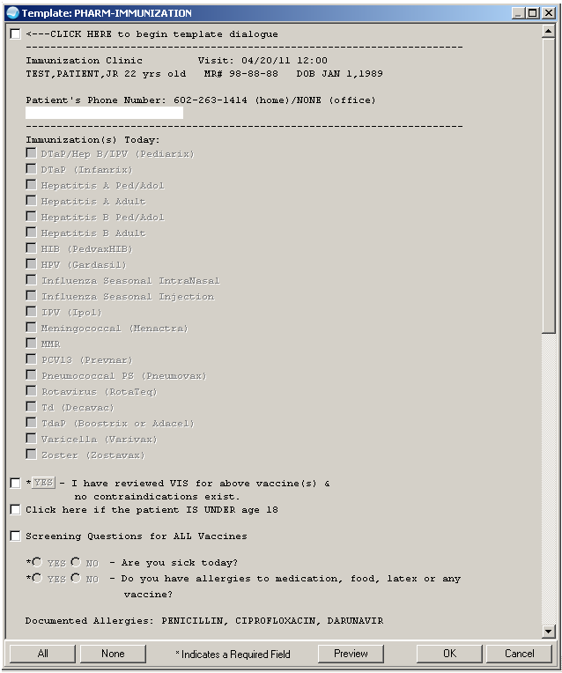

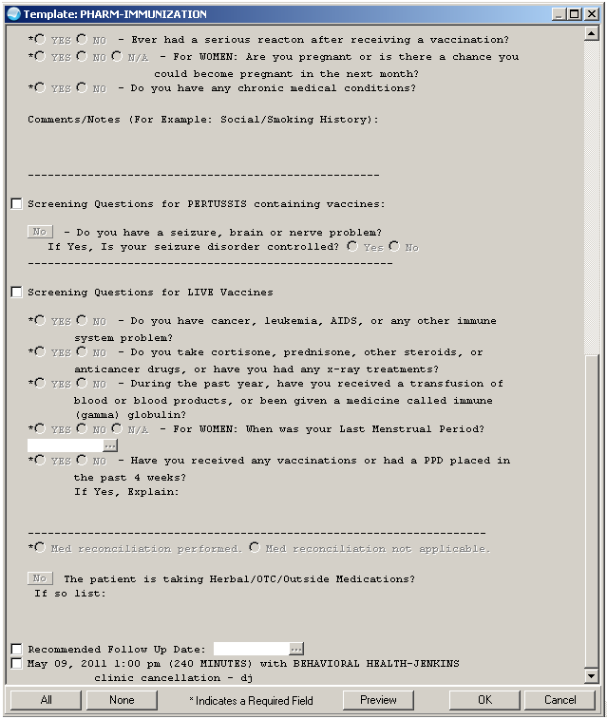

Appendix C: Interpretation of Titer results – (From (insert acronym of Hospital/Clinic) Lab)

Varicella IgG
<0.8 = Negative
0.9-1.0 = Equivocal
≥1.1 = Positive
VZV IgG is for the qualitative and semi-quantitative detection of IgG antibodies to Varicella (chickenpox) Zoster (shingles) in human serum by indirect immunoassay to determine prior exposure to VZV and, when evaluating paired sera, to aid in the determination of acute or convalescent stage of VZV infection.

Measles IgG
<0.9 = Negative
0.9-1.0 = Equivocal
≥1.0 = Positive
Measles (Rubeola) IgG is intended for the semi-quantitative detection of IgG antibodies to measles virus in human serum by indirect immunoassay, to aid in the assessment of the patients immunological response to measles virus

Mumps IgG
<0.80 = Negative
0.90-1.0 = Equivocal
≥1.1 = Positive

Rubella IgG
<4.99 = Nonreactive
5.0-9.9 = Equivocal
≥10 = Reactive

Hepatitis ABC Immunity Profile (Combined)
HEPATITIS A AB, TOTAL
HBs Antibody
HBV CORE TOTAL AB
HEPATITIS C, 2ND GEN.
When equivocal results are obtained, another specimen should be collected 10-14 days later and tested in parallel with the initial specimen. If the second specimen is also equivocal, then the patient is negative for primary or recent infection and equivocal for antibody status. If the second sample shows a significant increase in antibody level, the patient may be considered to have a primary infection. The timing of specimen collection for paired sera may be critical. In some patients, antibody titers may rise to significant levels and fall again to lower undetectable levels. Culture results, serology, and antigen detection methods should all be used along with clinical findings for diagnosis.

Appendix D: Medical Management of Vaccine Reactions Protocol
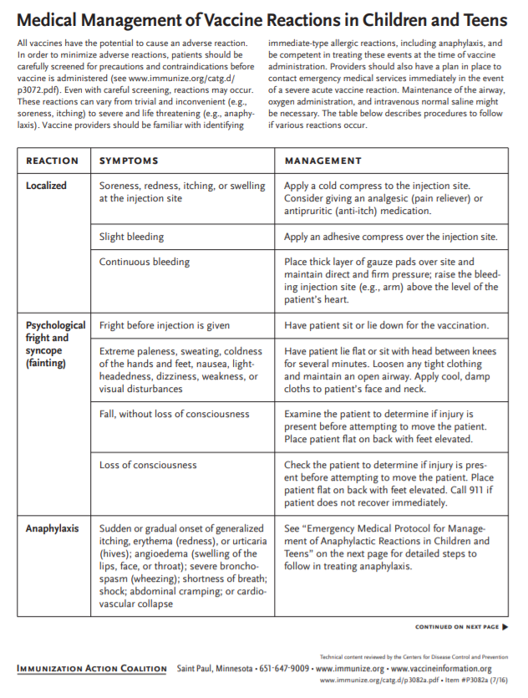
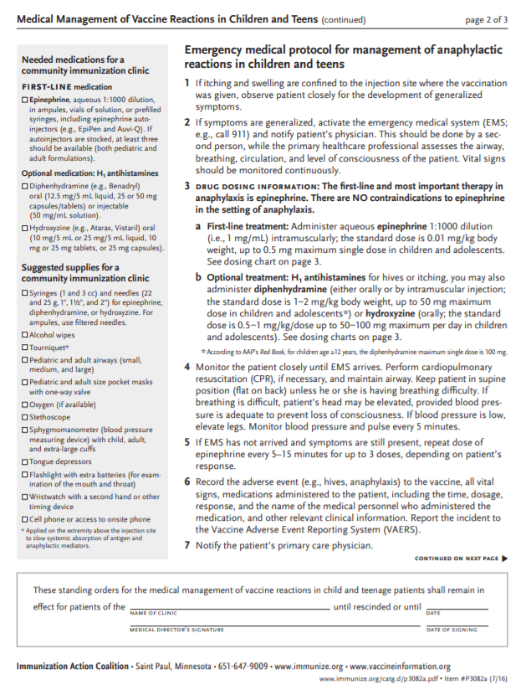
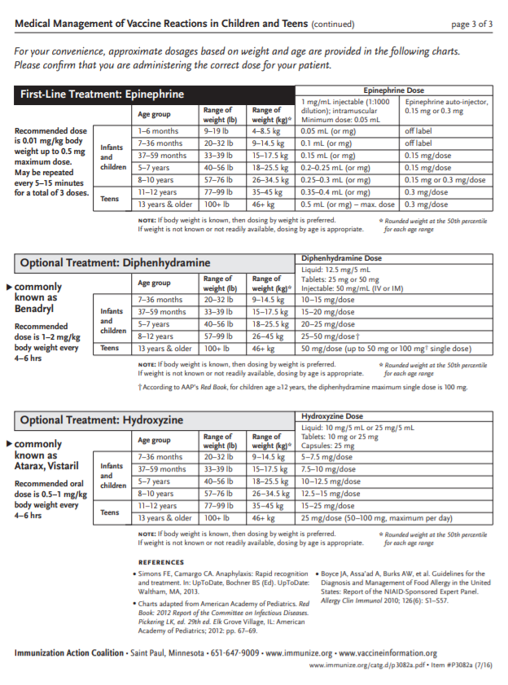

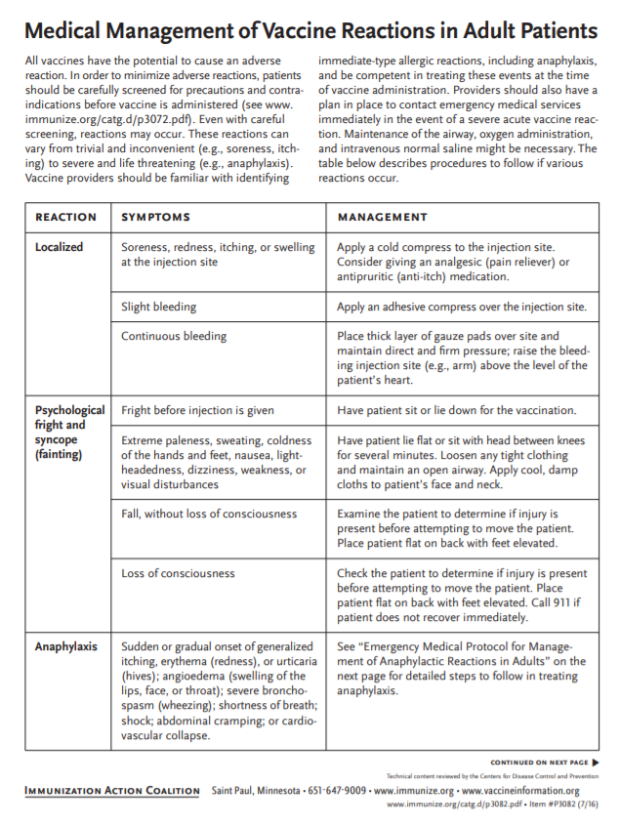
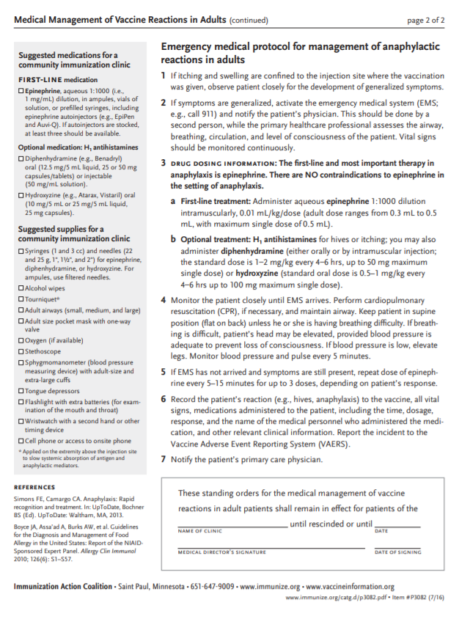

Appendix E: Example Immunization Table
EXAMPLE ONLY – MUST BE USED IN CONJUNCTION WITH FOOTNOTES
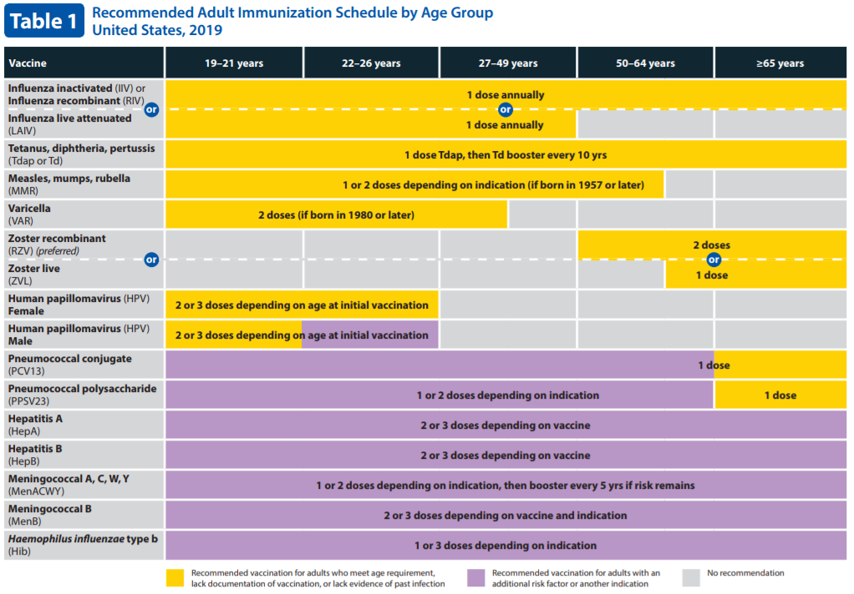
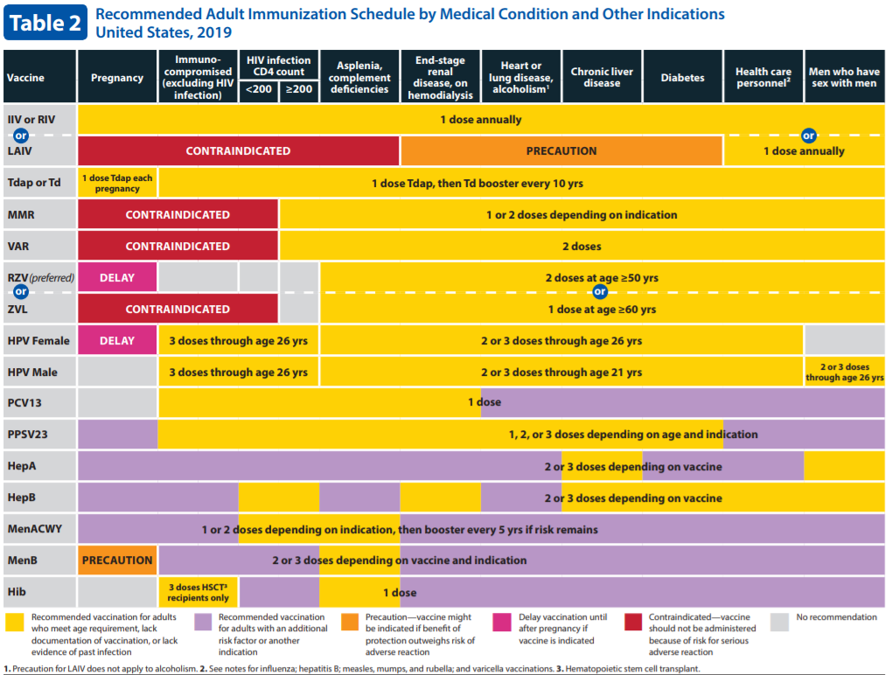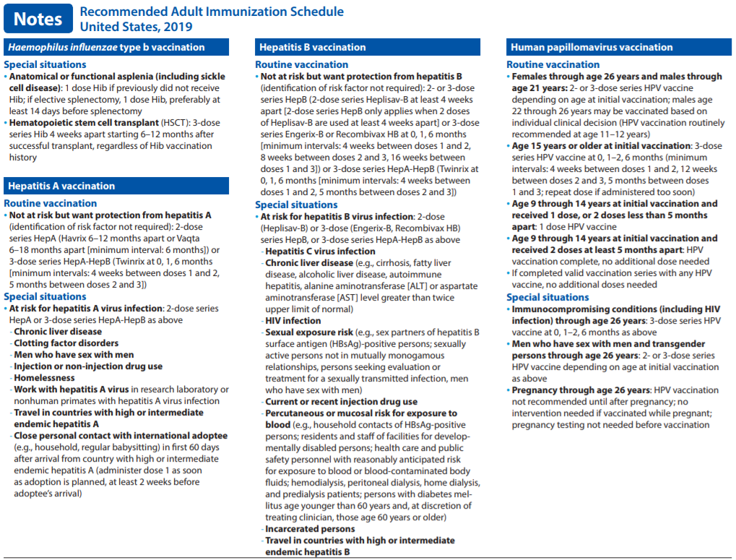
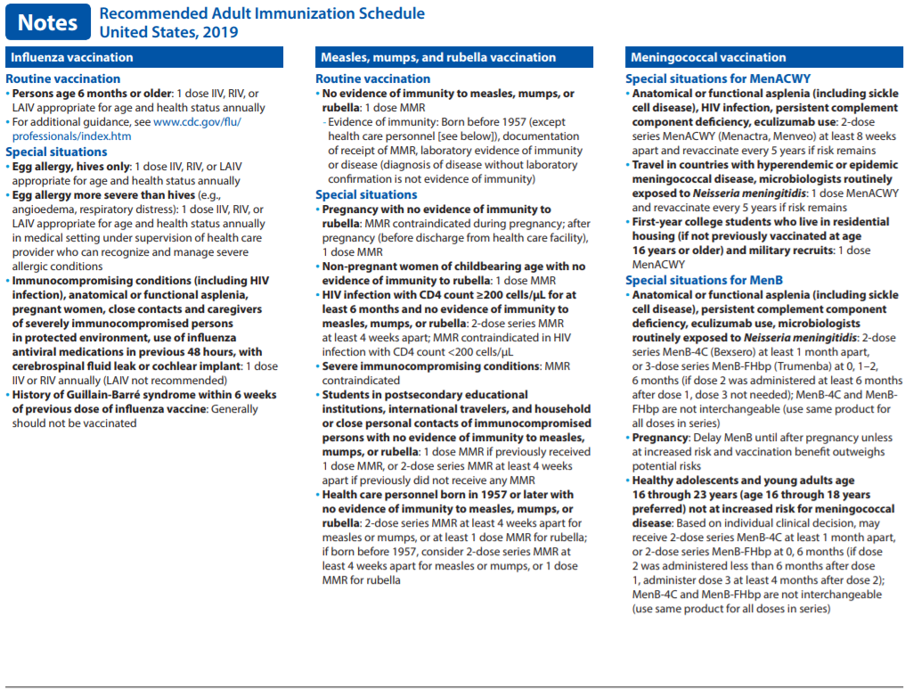
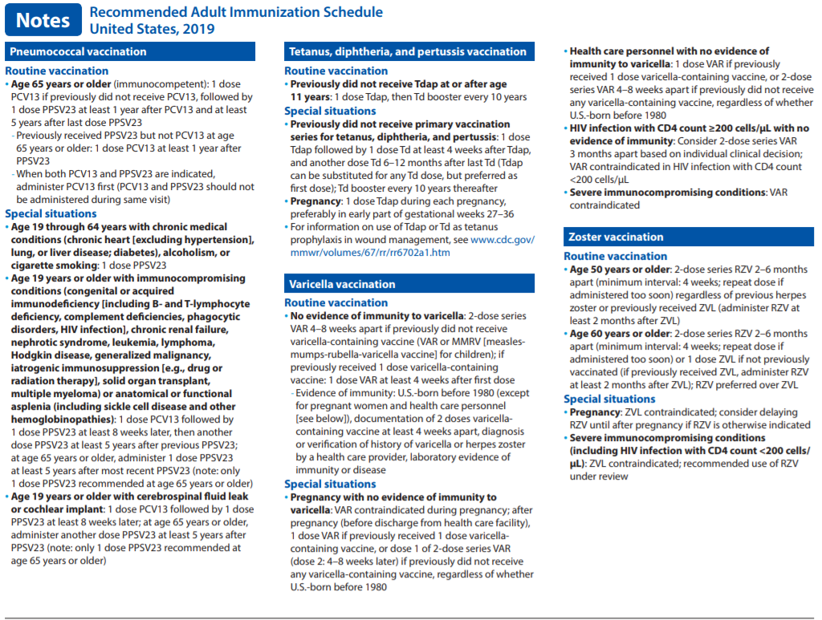

Appendix F: Example of a Disease State Guidance Document
Guidelines for Vaccinating Pregnant Women

Appendix G: Outcomes Data Templates (example)

CHART REVIEW

Name of reviewer
Name of provider administering vaccine
Chart number
Vaccine(s) Administered
Did patient meet clinic eligibility criteria? (ex. Age, (insert acronym of Hospital/Clinic) patient) | YES | NO
Clear documentation of current VIS given | YES | NO
Immunization clinic note completed | YES | NO
Immunization documented in immunization package | YES | NO
Allergies documented | YES | NO
Appropriate screening questioned asked | YES | NO
Are the “yes” answers explained | YES | NO | N/A
Medication reconciliation done | YES | NO | N/A

EVALUATION AND OUTCOMES DATA
PHARMACY BASED IMMUNIZATION CLINIC
YEAR ______

- NUMBER OF ADVERSE DRUG REACTIONS REPORTED

- NUMBER OF MEDICATION ERRORS REPORTED

- NUMBER OF CLINIC PROVIDERS

- NUMBER OF PATIENT VISITS

- IMMUNIZATION SUMMARY

Vaccine Name | Number | % of total
Total

- CLINIC PROVIDER SUMMARY

PROVIDER | INTIAL TRAINING DATE | OSHA TRAINING DATE | CURRENT BLS (YES/NO) | INJECTION TECHNIQUE (PASS/FAIL) | COMPETANCY TEST (PASS/FAIL) | CHART/PEER REVIEWS (2-4)

- DETAILS OF UNACCEPTABLE CHART/PEER REVIEWS

- INSERVICES/CONTINUING EDUCATION

- OTHER

Appendix H: Skills Assessment
(Insert Duty Station Acronym) Pharmacy Immunization Clinic Skills Assessment |  | Self-Assessment* |  | Evaluator’s Assessment
Competency | Skills, Technique, and Procedure | Need to Improve | Meets or Exceeds | Need to Improve | Meets or Exceeds | Plan of Action
A. Baseline Knowledge | 1. Understands how to properly handle vaccine to be wasted (i.e. dropped/broken/not used) | ☐ | ☐
 | 2. Understands vaccine expiration dates once vial is opened | ☐ | ☐
 | 3. Knows location and understands current CDC Immunization Schedules, Pink Book, Guides to Screening Questionnaires, Vaccine Information Statements (VIS), and Policy & Procedures for clinic | ☐ | ☐
 | 4. Understand Emergency Protocol if a patient is experiencing a serious adverse reaction after receiving vaccination(s) | ☐ | ☐
B. Preparation | 1. Screens for vaccine contraindications with the aid of the Screening Questionnaire | ☐ | ☐
 | 2. Understands how to access ASIIS database and knows how to document historical vaccines given into (insert appropriate Acronym for facility’s EHR system) from outside providers | ☐ | ☐
 | 3. Knows when to select VFC vs Non-VFC vaccines | ☐ | ☐
 | 4. Selects appropriate needle sizes for both IM and SubQ injections for infants, adolescents, and adults | ☐ | ☐
 | 5. Shakes vial prior to drawing up vaccine(s) and properly reconstitutes vial(s) requiring mixing (e.g. MMR, Varicella) | ☐ | ☐
 | 6. Appropriately draws up ENTIRE contents of single-dose vials for administration to patient | ☐ | ☐
 | 6. Offers VIS to patient for EVERY vaccine to be given and provides ample time for patient to review and ask questions | ☐ | ☐
 | 7. Verifies with patient vaccine(s) to be given BEFORE preparing the vaccine(s) | ☐ | ☐
 | 8. Double-checks expiration date, route, dose, and the correct vaccine(s) to be given | ☐ | ☐
C. Administration | 1. If patient is a child, properly instructs parent/guardian how to hold the child still | ☐ | ☐
 | 2. Preps site with alcohol wipe using a circular motion from the center to a 2" to 3" circle and allows alcohol to dry | ☐ | ☐
 | 3. Correctly identifies anatomic landmarks and uses proper technique for IM and SubQ injections for peds vs adults | ☐ | ☐
 | 4. Uses proper technique for preparing and administering Oral (e.g. Rotarix) vs Intranasal (e.g. FluMist) vaccines | ☐ | ☐
D. Misc. | 1. Correctly documents vaccine(s) given into (insert appropriate Acronym for facility’s EHR system) | ☐ | ☐
 | 2. Properly disposes of materials used (i.e. sharps vs trash) | ☐ | ☐
 | 3. Appropriately counsels immunization clinic patients (e.g. ADE's, follow-up, monitoring) | ☐ | ☐

* “Need to Improve” indicates further study, practice, or change is needed. “Meets or Exceeds” indicates performance is at expected level of competence or higher. It is for your own benefit to be honest!

Immunizer’s Signature: __________________________ Date: ________________

Evaluator’s Signature: __________________________ Date: ________________

☐ Pass
☐ Fail (repeat needed)

