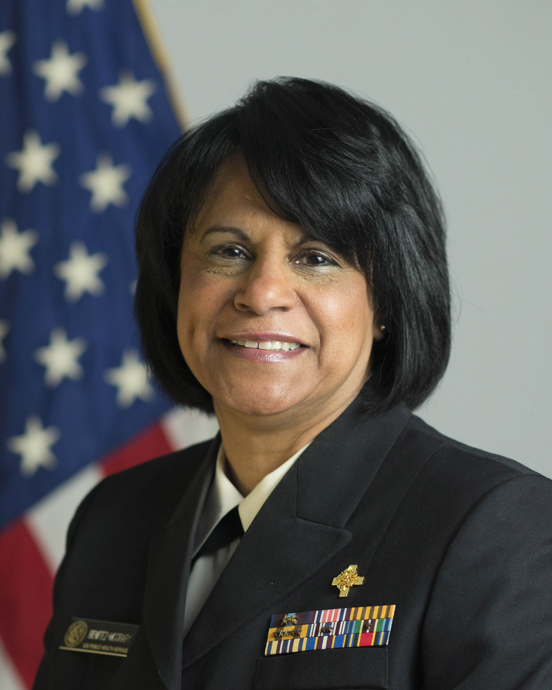

Captain Mercedes Benitez McCrary
Chief Professional Officer, Therapy- U.S. Public Health Service

Captain Mercedes Benitez McCrary possesses more than thirty years of public health, and patient care experience. Her career includes service as a public health service commissioned officer, provider of direct patient care, graduate university faculty, researcher, emergency deployment team commander, clinic administrator and community volunteer.

CAPT Benitez McCrary is a board certified Speech Language Pathologist, and specializes in the treatment of the traumatic brain injured patient, (TBI), and dysphagia rehabilitation.

CAPT Benitez McCrary is currently a Senior Advisor in the Learning and Diffusion Group, (LDG) in the Center for Medicare and Medicaid Innovation, (CMMI) at the Centers for Medicare and Medicaid Services (CMS). She is also serving as the Lead Project Officer for Healthcare Innovation Challenge Grants. The Healthcare Innovation Challenge grants were created as part of the Affordable Care Act of 2010 to identify new and innovative solutions that would improve healthcare quality, patient satisfaction while reducing costs.

CAPT Benitez McCrary was initially commissioned in the Commissioned Corps of the U.S. Public Health Service (USPHS) in 1978 and re-commissioned in 2001. During her career she has served as Clinical Speech Language Pathologist, Clinic Director, Senior Public Health Analyst, Special Assistant, Division Director, Deputy Office Director and Senior Policy Advisor. However during her leave from USPHS, CAPT Benitez McCrary served as Senior Speech Language pathologist at Howard University Hospital and Lecturer in the Department of Family Practice / Physical Medicine and Rehabilitation of the Howard University College of Medicine. In addition, CAPT Benitez McCrary served as the Executive Special Assistant to the President of the University of Medicine and Dentistry of New Jersey, (UMDNJ).

Throughout her USPHS career she has served in several leadership roles including as Commander of the REDDOG-Services Access Team 1, (SAT), & and as a member of the Rapid Force Deployment Team, (RDF-1). She has deployed to several national emergency disasters and served in the Federal Emergency Management Administration command center (FEMA), and the DHHS Secretary’s Command center (SOC). She served as the inaugural President of the Baltimore branch of Commissioned Officers Association, (COA) and as Vice Chair of the Hispanic Officers Advisory Committee ( HOAC). In support of the Therapy Professional Advisory Committee, (TPAC) she has served as co-chair and chair of the TPAC Category Day, at the COA Annual Professional symposium and as a TPAC voting member . CAPT Benitez McCrary has served as a member of the TPAC promotion and mentorship sub-committees.

CAPT Benitez McCrary has authored and published several research articles in fluency disorders, health literacy, aphasia and dysphagia rehabilitation in peer-reviewed publications.
CAPT Benitez McCrary received her Bachelor of Arts degree and a Master of Arts in Speech Language Pathology from The George Washington University. She has also received an advanced certificate in Public Health leadership from The Johns Hopkins University. CAPT Benitez McCrary has completed her Doctorate in Health Sciences from A.T. Still University. She has been the recipient of several national honors recognitions and awards from professional organizations, the USPHS, civic associations, religious groups and the Alpha Kappa Alpha Sorority, Inc.

CAPT Benitez McCrary is a fluent Spanish language speaker and her family originates from Puerto Rico. The Captain and her spouse, Dr. Victor McCrary reside in Maryland with two adult children, Francesca, a graduate of The Citadel Military College ’12 and Cadet Maximilian attending the U.S. Coast Guard Academy.

